Ideas for Technology Integration for Gifted Students
By Heather M. Miller, 2018
Table of Contents
Ideas for Technology Integration for Gifted Students 1
List of Lists: Teaching Tech with Gifted Students 3
My school webpage 3
My school webpage with teacher resources. 3
My personal webpage that includes my school webpage 3
My personal webpage 3
My personal blog 3
Choice Boards Integrating Technology 4
Things Teachers Integrating Technology Probably Should Know…. 6
SAMR Model 6
BLOOMS Taxonomy and Technology: 7
Powerful Catch Phrases for Teaching Technology. 7
Class/Group/Teacher Led Instruction 9
AnswerGarden 9
Verge (Computer Lab Course) 9
Discovery Education Network 9
Flipgrid 9
Individual Instruction and Experiential Learning 10
Adobe Spark (ipone App) 10
Aurasma / HP Reveal 10
BreakOut Boxes 10
Code.org 11
iPad Apps 11
Kahoot! 11
Keyboard Shortcuts 12
Launchpad (Computer Lab Channel of Links) 12
Microsoft Excel - The Many Faces of 12
Microsoft Office Suite 13
MS Paint (simple, quick drawings) 13
Music (Multiple apps and ideas) 13
Online STEM Notebook 14
Osmo – Pizza Company 14
Osmo – Coding Awbie, Coding Duo & Code Jam 14
Osmo – Detective Agency 15
Osmo – All Apps & Games 15
QR Codes 16
Robots –Generally 16
Robots – Dash and Dot Show & Story Telling Robots 16
Scratch 17
Snipping Tool (Screen Shots) 17
Stop Animation / Stop Motion Animation 18
StoryboardThat.com 19
Symbaloo 20
Tagul Word Art Creator 20
Timeliner 20
Tinkercad 20
Turing Tumble 21
Visuwords 22
Website Analysis 22
Website Creating 22
Wordle and Tagul 22
YouTube & Google 22

List of Lists: Teaching Tech with Gifted Students
Technology is one of my favorite things to work with. I am also a list creator. I make lists of lists. I did gifted-endorsement in 2017-2018 and compiled a lot of stuff for that class. I add to my lists a lot, and have a ton of things stashed here and there. I am constantly getting emails to try this or that product out. I am also always searching. I’m also a sharer, so here you go….

My school webpage
  - http://oakcliffes.dekalb.k12.ga.us/HeatherMiller.aspx

My school webpage with teacher resources.
  - This is a huge list of websites that I’ve found interesting, helpful, or totally stink (and I tell you to not waste your time with those).
  - http://oakcliffes.dekalb.k12.ga.us/TeacherResources.aspx

My personal webpage that includes my school webpage
  - Hover on OLD HOMEPAGE and you’ll see a list of all the sub-pages
  - http://www.industriousteacher.com/oldhomepage.html

My personal webpage
  - http://www.industriousteacher.com/

My personal blog
  - http://www.industriousteacher.com/blog

Choice Boards Integrating Technology
Choice Boards are how I would suggest you incorporate technology into subject area teaching. You do not have to offer EVERY PROGRAM to the children for EVERY project…but for goodness sake, offer at least one Tech option always. Here is a generic example for gifted kids:
(9 points) Create a stop animation – any form – acting out or demonstrating the topic of the week. Use the ipad app iMotion.  Add a Soundtrack for an additional point. (10 points total) | (8 points) Evaluate the pros and cons of “taxation” (fill in your big topic). Present your work using any form of technology – you convince me, or our classroom blog. | (7 points) Create a 3D model of the topic using TinkerCad. Leave the model in multi-color, and copy it with the file merged into an .STL File for 3D printing.
(6 points) Graphic Novella  Present an alternate ending, alternate universe, using StoryboardThat.com. Scenes, characters, text boxes, at least one close-up, variety of panel sizes. | (6 points)  Create a Scratch App that demonstrates your understanding of this unit’s concepts. | (5 points) Create a MASHUP of two or more concepts you have learned in the past or research now. Include 5-10 of this unit’s vocabulary. You pick the medium you present in.
(2 points) Type your vocabulary list (word and definitions) using Microsoft Word, PPT, or Sway. Put one definition per page/slide/card. Use font size & type, color to make your word memorable. Add picture or a gif & write a caption. | (4 points) Create 4 Aurasmas (HPReveal) of the vocabulary words. You must print/draw on paper all of the target images. Record the video, color pictures, URLs | (3 points)  Create a Vocabulary Quiz in Zahoot!  Type your vocabulary list (word, definition, and picture) using Microsoft Excel. Use the export and upload in Kahoot.
(1 point) Play Vocabulary.com’s vocabulary challenges to get your highest score. Play at least 3 games to get your highest score. THEN Copy your list of new vocabulary that you worked with. Create a WORD Picture using Tagul. Make your favorite 5 words larger than the rest. Be creative. Save your Tagul Word Art image to your network drive. | (5 point) Visit Ms. Miller’s Verge List of Files and explore a topic of your choice for 30-60 minutes. Present your findings in a 30 second video, 30 second (5 images for 6 seconds PECHAKUCHA video PPT.) | 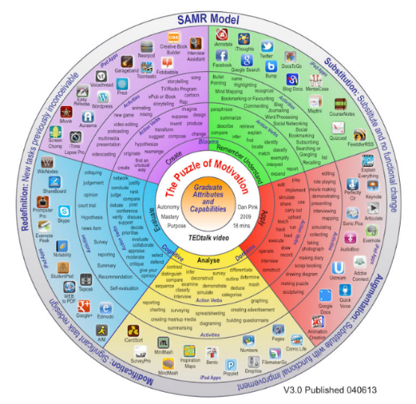  ( _____points) Convince me. You choose a platform, program, app, etc. that will allow you to show your talents and creativity in a novel project. Use: https://blogs.osc-ib.com/2014/07/ib-teacher-blogs/dp_web/convergence-samr-model-action-verbs-activities-and-technologies/ for help with program choices.

Things Teachers Integrating Technology Probably Should Know….

SAMR Model
Dr. Puentedura created a technology model, called SAMR. You’ll come across as you begin to integrate more technology into the classroom. It looks like this: 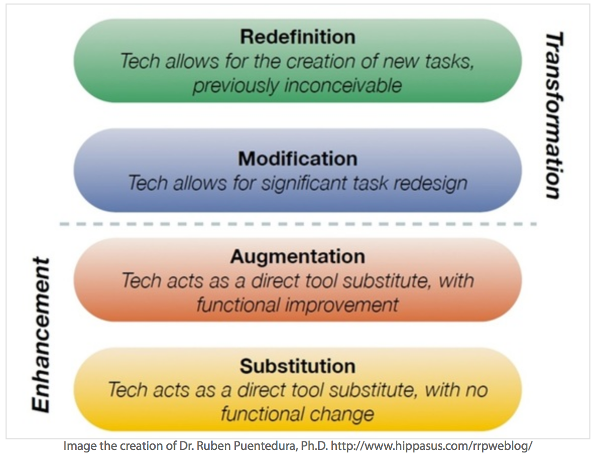
Then Dr. Puentedura created a second model that links it to Bloom’s Taxonomy found here. It looks like this:
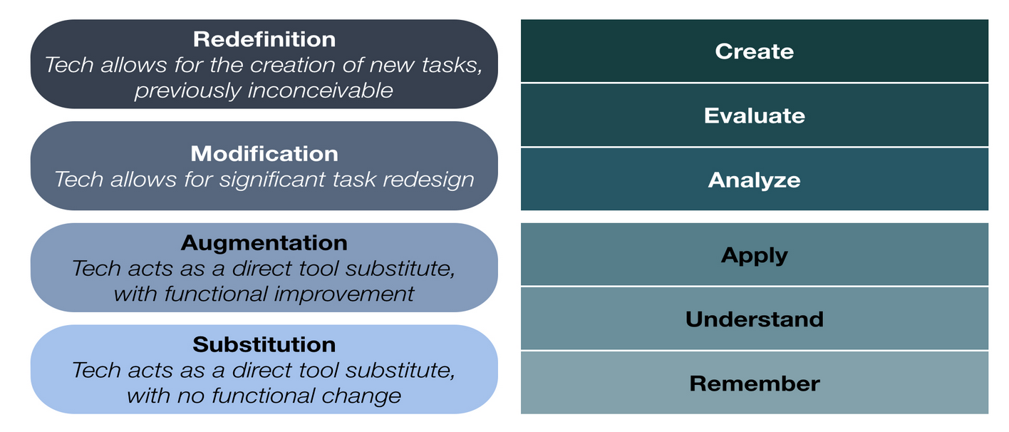
Here is an interpretation by Kathy Schrock here:
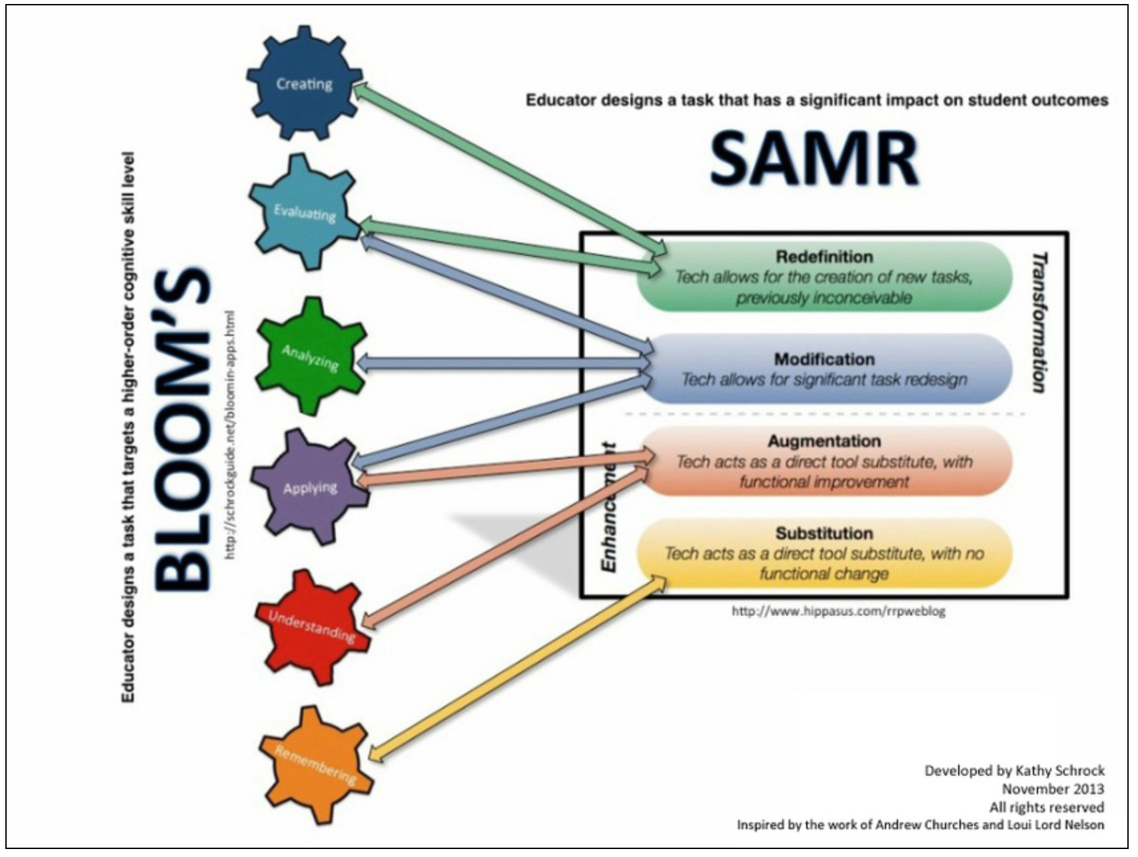
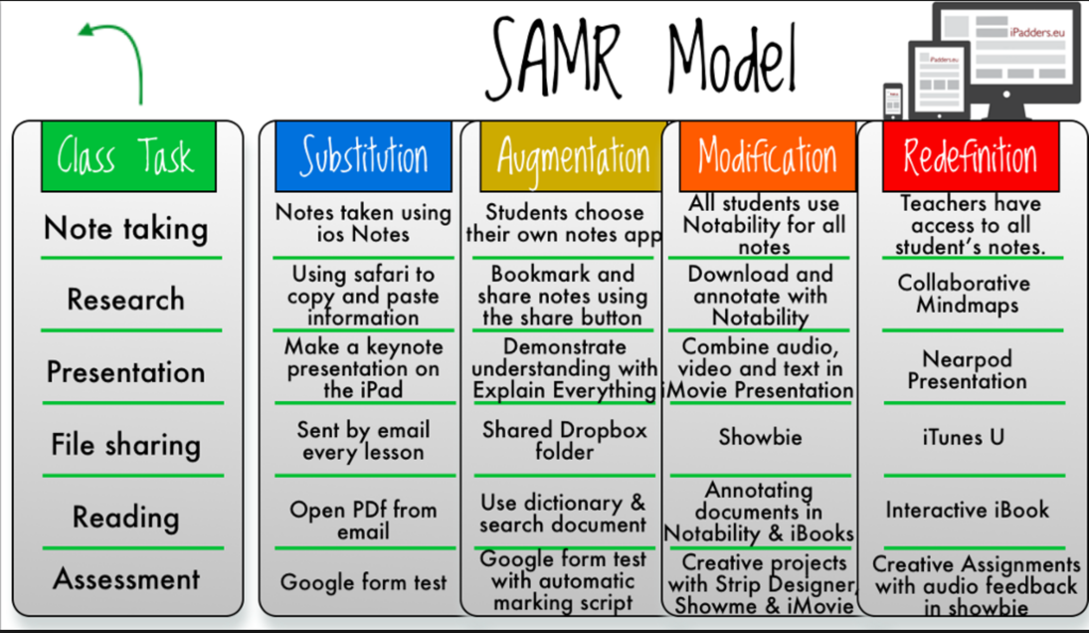
This is an interactive introduction from Kathy Schrock’s page by ipadders.eu. You’ll have to scroll down. http://www.schrockguide.net/samr.html

BLOOMS Taxonomy and Technology:
If you want to read more on SAMR & Bloom’s taxonomy and DOK, this is a great resource: https://blogs.osc-ib.com/2014/07/ib-teacher-blogs/dp_web/convergence-samr-model-action-verbs-activities-and-technologies/
This is a tiny version of the picture at the above site. It shows you programs in the outer rings and the action words in the middle rings. It’s correlated to each level of Bloom’s Taxonomy and the SAMR Models.
You can’t know everything! So don’t sweat that you don’t. Be honest and flexible. Technology has so many ways to do the same thing, that it’s OK to not know every way to do everything.

Powerful Catch Phrases for Teaching Technology.
In teaching technology to gifted kids, you as a teacher don’t need to do much more than get the kids started…they figure it out as they go. I teach them how to experiment, try things; CTRL+Z undoes whatever the last thing was…
As a tech teacher, my two most powerful statements are:
“Hey have y’all seen this?” and
“I don’t know…how would you find out that answer?”
With that said, if I give a kid a program name, I have at least looked at it and played with it myself. I’ve watched a few YouTube intro videos. Or, I am honest, and I use my third most powerful statement:
“I have no problem with you using that software, but I do not know it, so you’ll have to use it on your own, with minimal help from me.”
The good thing is that a lot of technology, software especially, is repetitive with similar features that work across many platforms. By the way, my fourth preferred statement is:
“Let’s find out together.”

Class/Group/Teacher Led Instruction

AnswerGarden
- Answer Garden is a class/group collaboration model.
- This could work as an exit ticket, especially if you needed to track data.
- http://oakcliffes.dekalb.k12.ga.us/TeacherResources.aspx

Verge (Computer Lab Course)
- Send the Discovery kids to the computer lab page in Verge. I am constantly adding things of interest to the highly interested.
- Create your own online course through Verge. It allows you to differentiate for groups of kids.

Discovery Education Network
- This is NOT Discovery Channel Online. That is the TV show.
- http://www.discoveryeducation.com/
- DEN is a fantastic collection of resources. You have to sign in to use them. Use your teacher account.
- There is a video watching interactive quiz you can create over top of YouTube videos that is amazing.
- There are hundreds of STEM career voices, activities, ideas, etc.
- It’s an amazing resource.

Flipgrid
- Flipgrid allows students to record short, semi anonymous video responses to a teacher generated prompt.
- I could see a use for this app in a gifted classroom. Most elementary students don’t have their own device, so the teacher could control the device and moderate responses in a way that would make sense for certain assignments.
- The disguises, glasses, funny hair, etc, make the face of the respondent different enough that kids could talk and have their voices recorded.
- https://flipgrid.com/
- I have not used Flipgrid in the classroom yet. I just got ipads recently.

Individual Instruction and Experiential Learning

Adobe Spark (ipone App)
- Adobe Spark is a neat online, animated graphic design program that turns graphic designs into repeatable animations using themes, colors, and stylish animations.
- I did a full write up here on 7/25/2018 http://www.industriousteacher.com/blog

Aurasma / HP Reveal
- Aurasma went through a name change and is now HP Reveal. It is an augmented reality APP that allows target images to reveal video, links, etc. as picture QR Codes.
- https://www.hpreveal.com/
- I did a full write up on it here.... http://www.industriousteacher.com/teachers.html

BreakOut Boxes
- https://www.breakoutedu.com/
- Consume: There are a multitude of physical, online, and both games on many topics, themes, and subjects. Each game is supposed to contain all clues to unlock the boxes. This format allows for wide a variety of thinking and communication styles, teamwork and collaboration. As a teacher, setting up a student game is time consuming the first time. Use a premade game. Allow loners to work alone or in a very small group. Monitor heavily for cheating.
- Create: The idea is that the games can be created to any subject matter and any game. Before creating an original game, students should play at least two games. Oakcliff has two physical boxes at school, and we have digital access to a bunch of games as well. There is a vast digital library of locks as well.
- Caution: There is a tendency in some to cheat. Creating games around cheaters is hard, and frustrating. It can sabotage the experience for all involved. Be mindful that there are a lot of layers that intrigue gifted students about the creation and the playing of breakout boxes. The players might need to be reminded to keep the spirit of the game in mind and to remain flexible and positive. This is especially true if the game is the first creation of the gifted student game creator.

Code.org
- Our Oakcliff School’s Code.org Login Page: http://oakcliffes.dekalb.k12.ga.us/CodeLogins.aspx
- Code.org’s regular home page http://www.code.org
- All Oakcliff students have a Code.org login.
- There is no code club this year, but there will be in the future. Until then, any student can log in and get to the platform and self-teach themselves CS (Computer Science) principles.
- Create: This is a creation tool. Real computer science concepts are being practiced. The kids think it’s a game.
- This is a great exercise for repeated practice and early finishers in MATH and ELA.
  - To focus on math, have students go to “The Artist” who will demand use of angles, shapes, and algorithm creations to make many 2D shape drawings.
  - To focus on story telling & alternate endings & fables & mashups, have students go to “Play Lab” and create Sprites who say and do things when other characters do certain things.
  - To focus on in depth course integration, have students go to Scratch and create a universe (ex. The woods with a path for Little Red Riding Hood) (ex. The ocean floor with a path for Little Red Swimming Fish).
- Famous for Hour of Code. https://code.org/hourofcode/overview
- Any Hour of Code can be used by anyone without a login. Their info won’t be saved thought, but it’s a great way to explore interests.
- ONLINE and OFFLINE activities are well tested and build for success.
- Code + Tinkercad = CodeBlocks…..it’s amazing!!! https://www.instructables.com/id/Hour-of-Code-Make-Patterns-With-Code-and-CAD-in-Ti/?mktvar002=1034937

iPad Apps
- I create a list of ipad apps two years ago. I present it to you so that you might make a decision if these apps are of use to you and your student’s education. Many are special ed, but some were listed with gifted ed in mind.
- http://oakcliffes.dekalb.k12.ga.us/Apps.aspx

Kahoot!
- Consume: Teacher usually assigns games or challenges. Students can search and let you know what they are interested in.
- Create: Students can create their own kahoots! Class games, or challenges.
- Mass Create: If a student (or teacher) has a mass of questions and answers to upload, and the question and answer set is in Microsoft Excel, it can be mass uploaded as a challenge or as a class game.
- Caution: While class games are fun for some, the wide variety of interests of gifted kids, and the time pressure and social aspect of Kahoot Classroom games can shut the kids down. Too many questions, the kids will calculate they won’t win and might give up.

Keyboard Shortcuts
- CTRL+C (Copy)
- CTRL+V (paste)
- CTRL+B (Bold)
- CTRL+Z (Undo) CTRL+Z is your best friend. It lets you teach kids to try things, then undo if you don’t like the outcome.
- ALT 168 is the ¿
- ATL 173 is the ¡
- The kids can search for “keyboard shortcuts for ___name the program___”

Launchpad (Computer Lab Channel of Links)
- Send the Discovery kids to the computer lab page in Launchpad. I am constantly adding things of interest to the highly interested.
- Visit yourself to get ideas.

Microsoft Excel - The Many Faces of
- Microsoft Excel is a gifted student’s dream, if they can get past the mini-nightmare of their teachers NEVER assigning this program to them.
- For the mathematically gifted student, Excel is a power iteration machine.
- Google what you want to do in Excel…there are millions of 60 second tutorials.
  - Charts & Graphs
  - 10-Frames in Excel or MS Paint
  - Calculations (basic formulas)
  - Time Lines
  - Number Lines
  - Random character name generator
  - Pixel Art
  - Because there is an underlying grid, Excel can also be forced into a fairly powerful layout and design program.

Microsoft Office Suite
- Word, PowerPoint, Excel Desktop vs ONLINE
- Online is the basics…but there are things that are nicer, easier, more efficient in the online versions. Desktop is the more robust of the two platforms.
- PechaKucha Style PowerPoint 20x20x20 – A more efficient way to present a PowerPoint
- PowerPointONLINE vs PowerPoint OFFLINE(Desktop)
- SWAY (online). This is really simple presentation program that is like if PowerPoint and the Internet had a baby. It’s the best of both programs. It is very visual and super simple to figure out with a few how-to intro videos.

MS Paint (simple, quick drawings)
- Ability to create drawings for online notebooks, or other purposes…Rapidly.
- Use Snipping Tool to copy and paste the drawing to the WORD or other program.

Music (Multiple apps and ideas)
- Music, especially background music is related to stop animation; making background music increases the quality of those stop animation videos discussed above. And it is fun to add to PowerPoint presentations as well. Sometimes music is simply the passion.
- A simple 1-person to 4-person ipad music studio is also made by Fingerlab. It’s called Rockmate and works best on ipads because of the movement needed to create really cool stuff. It looks like instruments.
  - Rockmate - http://fingerlab.net/portfolio/rockmate
- Fingerlab also created a visual music creation tool. The shapes fall, you add things the balls hit, bounce, slide, etc. There is no way to describe it other than to watch the short video.
  - Musyc - http://fingerlab.net/portfolio/musyc
- Fingerlab also has a nice Digital Effects (Sound Effects) machine “DFX – Digital Multi-FX” with an intuitive interface. It’s simple and fun.
  - http://fingerlab.net/portfolio/dfx
- Garage band is also available on Macs and ipads.
  - Garage Band is more than most elementary students can handle, but there is always that one kid who would enjoy it and spend the time playing with it to get some really good music created. We have Garageband on a mac in the computer lab. You don’t need to know how to read music or any music skill at all other than patience to trial and error what you like to hear.

Online STEM Notebook
- I have created an Online STEM Notebook Template. You can differentiate with more or less information filled in for the kids.
- The students can add the hand drawings in MSPaint, or 3D designed items into the STEM Notebook. Those can serve as Ideas and Plans….
- Data sets can also be typed into Excel and charts and graphs can be added.
- The document can start as a small template, and as kids add information, the document just adds pages.
- I also added a Table of Contents at the beginning, which the kids can navigate the document using the VIEW NAVIGATION PANE.
- To update the Table of Contents after you’ve added a bunch of information, Right Click on the Table of Contents. Choose Update….Entire table…ENTER.

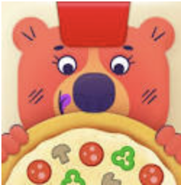
Osmo – Pizza Company
- https://www.playosmo.com/en/pizza-co/
- Osmo has a mission to make the online and real world interactive. Their products use an online interface, but use real life physical things to interact with the electronics.
- Osmo Pizza Company would be great in a gifted room, or corner where the kids could spend some time early finishing (Kinder – 2nd grade Discovery students.)
- Working as a team, students make pizzas based on the customers’ wishes for the pizza toppings, count money, make exact change, and spruce up the restaurant. There is an additional element of book keeping, which gifted kids might enjoy. The data can be journaled and imported into an Excel spreadsheet for all sorts of graph designing fun.

Osmo – Coding Awbie, Coding Duo & Code Jam
- I bought this for my son several years ago when it was just Coding. He loved it. The codes are tiles on the table, and Awbie, the strawberry eating creature follows the commands through the forest and mazes on the screen. There is a newer version called Coding Awbie.
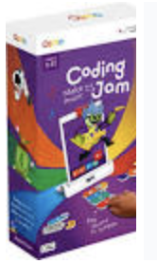
- Coding Awbie - https://www.playosmo.com/en/coding/
- Coding Jam – music and coding... https://www.playosmo.com/en/coding-jam/
- Coding Jam tutorials - https://my.playosmo.com/coding-jam
- Coding Duo – Awbie + Mo a second monster... https://www.playosmo.com/en/coding-jam/

Osmo – Detective Agency
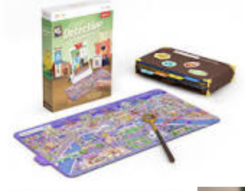
- This is a newer Osmo game. It has booklet boards that are pictographs of 8 maps of countries. There are mysteries that must be solved based on a “Where’s Waldo” kind of search, and a Carmen Sandiego set of clues.
- I haven’t used it but it looks good for a younger Gifted classroom.
- https://www.playosmo.com/en/detective/

Osmo – All Apps & Games
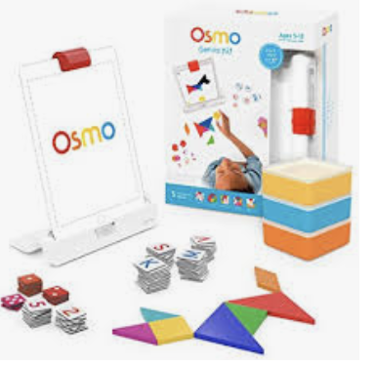
- I bought Osmo when it first came out several years ago. They have added so much depth to their products. Words and Numbers were their first games. They had a basic set of words and a basic set of math problems and numeracy concepts.
- There is a teacher forum where educators can connect to lesson plans and talk to each other. https://my.playosmo.com/forums
- They have opened up the world to the Osmo community, and community members have created all sorts of add-ons that make even the most basic word games challenging enough for upper elementary gifted kids. Even the kids can get in on the creation of word sets. It’s like Kahoot! But with physical manipulatives.
- Examples of a user generated word sets. Basically anything you can turn into a fill in the blank, or multiple choice, you can create content & practice with Osmo Letters. Great for content vocabulary building.
  - fraction vocabulary - https://my.playosmo.com/words/album/1e0rfn6w16o
  - States and Capitals - https://my.playosmo.com/words/album/1p8yof3ztog
  - Riddles - https://my.playosmo.com/words/album/1pha08ie4g0
  - US Presidents - https://my.playosmo.com/words/album/1kp9m56heyo
  - Events leading to the Civil War - https://my.playosmo.com/words/album/1hlk1bykdmo
  - Continents and Oceans - https://my.playosmo.com/words/album/1jnhsu2q0ow
  - 10-frame counting -- https://my.playosmo.com/words/album/1k3xt9877y8
  - Geography of the Americas - https://my.playosmo.com/words/album/1p4lw84l81s
  - Landforms – recognize the picture, spell the word https://my.playosmo.com/words/album/1krcdpagow0
  - Dinosauras – recognize the picture, spell the word... https://my.playosmo.com/words/album/1kmzpa0shkw
  - Biomes – recognize the picture, spell the word - https://my.playosmo.com/words/album/1jy0sh4nnr4
  - Geometry – recognize the shape, spell the word – https://my.playosmo.com/words/album/1k2rx0my7eo
  - Body system – recognize it and spell the word - https://my.playosmo.com/words/album/1kd41719l34
  - American Revolution vocabulary words - https://my.playosmo.com/words/album/1c9kuiscmbk

QR Codes
- QR Codes are interesting to use with gifted kids. They can find new and creative ways to use them.
- I suggest if a kid is interested in QR Codes, you steer them towards Aurasmas in HP Reveals.

Robots –Generally
- I actually do not advocate giving kids, gifted or otherwise, robots in a classroom setting. There are many other software options. The kids do not have enough time to explore what a robot can do, so they take shortcuts to get the machine to work. There are many places to download the code, and most kids do not understand what the algorithm is doing.
- Groups of two are ideal, but really robots are controlled by one person and the other kid ends up being the gopher.
- If a teacher wants to host a multi-hour club or clinic, then the kids can dive into the programming of the robot for live-control or autonomous control of robots. I suggest one robot for every two kids, or 1:1 if possible.
- There are many robots in the school. They mostly get used as toys. I’m not convinced of their efficacy.

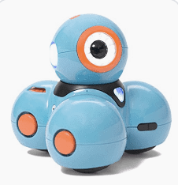
Robots – Dash and Dot Show & Story Telling Robots
- With the above statement made, robots can be used as part of STEM projects with some educational benefits of iteration, if the kids actually understand what the code is doing.
- Dash and Dot show – this is a series of videos starring Wally and Mimi, who i think are kids of the makers of Dash and Dot robots...they are either highly creative kids, with a lot of time, and movie making skills, or there are adults involved in their productions. The shows are creative and I can see gifted kids trying to create their own show.
  - Here is show #9 - https://www.youtube.com/watch?v=Fbe00eOSud4
  - Here is a playful take on the Hunger Games... https://www.youtube.com/watch?v=d6YDoViHE9U
- Robots to Freedom used the robot Dash to tell the story of the Underground Railroad. https://www.youtube.com/watch?v=RbymNJqFDEE

Scratch
- https://scratch.mit.edu/
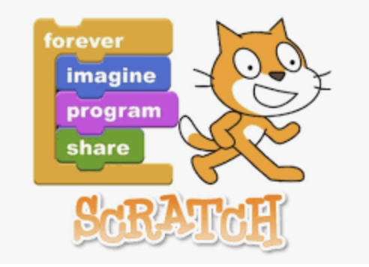
- Scratch is an MIT block based coding platform that allows kids to code their own highly interactive games. It is Code.org at the next level.
- All kids in Discovery have a Scratch login.
- To focus on deep course integration, have students create a GAME (This is called Game Design). Assign the grade level science, math, ELA, and social studies standards (historical places, map the city/state/country, battles of the Civil War, trains, etc.)
  - First, create a universe (ex. The woods with a path for Little Red Riding Hood) (ex. The ocean floor with a path for Little Red Swimming Fish).
  - Then students create the sprites (characters). (ex. Little Red Riding Hood and the Wolf) (ex. Little Red Swimming Fish and the Shark).
  - Then figure out the situations where the characters go, do, score points, lose points. One character is the protagonist (Little Red Riding Hood/Fish) who gets points by doing things and loses points for doing/not doing other things. The other character is the antagonist (wolf/shark). The environment can also be a character….wells, pits, traps, walls, things fall off trees, things grow on trees, etc.
  - There needs to be a clear point to the game. (Little Red Riding Hood/Fish is punished for veering off the path, rewarded for trusting instincts about the Wolf/Shark, arrives safely at Grandma’s House, gets the most points by ____, etc.)
  - Once one playfield is created in the universe, additional fields can be created (dark forest, open field, path diverges, pond path, etc.)
  - Finally, the kids in the class can play the game and give feedback on its “funness” and “challenging” and “problems” and then the creators can make a second iteration of the game.

Snipping Tool (Screen Shots)
- Ability to move most media (passages of words, pictures) from one place to another, rapidly.

Stop Animation / Stop Motion Animation
- Students can tell a story, mashup, alternate ending, new fable, etc…easily with a variety of methods, but all using some form of stop animation. It is time intensive and open ended – perfect for some gifted kids.
- What is Stop Animation? https://www.youtube.com/watch?v=wVjMFU11hVA
- Notes: Frame rate makes still pictures turn into moving pictures. It is a number followed by “fps” which means frames per second. The lower the number, the choppier the video will look. Video appears at 12fps and smoother video appears at 24fps. “12fps vs 24fps Stop Motion Animation Frame Rate Comparison” - https://www.youtube.com/watch?v=PFuB648-ZBY
- Lego – Legos are wonderful for Stop Animation because each raised circle can represent a single step, or movement. The Lego grids basically provide a template to help keep the action’s movements the same in each frame, and also the grid helps the animator the same distance from the camera.
  - Professional examples at YouTube https://www.youtube.com/channel/UCfFwvkI8a8tSWX2Z6Fn5zDg
- Whiteboard
  - Short 40 seconds: https://www.youtube.com/watch?v=p6aagonTcnQ&index=16&list=PLoR4NuvlhinuXeb501SJ2Q25sqRsCCx8r
  - https://www.youtube.com/watch?v=3GPg8djk5nY&list=PLoR4NuvlhinuXeb501SJ2Q25sqRsCCx8r&index=13
  - https://www.youtube.com/watch?v=6vZ0iqUS6sg
  - Toonator is an online white board animator program. https://toonator.com/
- Paper
  - Sticky note stop animation: https://www.youtube.com/watch?v=riFK2nvdjxM&list=PLoR4NuvlhinuXeb501SJ2Q25sqRsCCx8r
  - Cut and crumpled paper https://www.youtube.com/watch?v=ByGq-EdQ2L0&index=8&list=PLoR4NuvlhinuXeb501SJ2Q25sqRsCCx8r
  - Created in a paper notebook https://www.youtube.com/watch?v=BCtoxM77jLo&list=PLoR4NuvlhinuXeb501SJ2Q25sqRsCCx8r&index=11
- Object
  - Candy https://www.youtube.com/watch?v=3DFzjP6PbnU&index=2&list=PLoR4NuvlhinuXeb501SJ2Q25sqRsCCx8r
  - Variety of household objects https://www.youtube.com/watch?v=sOMFod_Qnhg&list=PLoR4NuvlhinuXeb501SJ2Q25sqRsCCx8r&index=9
- clay/playdoh
  - Google it...
  - Think Gumby, Wallace and Gromit, Nightmare before Christmas, ParaNorman, etc.
- Preferred Equipment (ipad/iphone apps that allow for pictures /cameras)
  - Imotion by FingerLab is by far the easiest for the ipad and iphone stop animation software I’ve found. I love the company that makes it as well. They do quality work.
  - http://fingerlab.net/portfolio/imotion
- Other Materials:
  - Image capture – ipad with stop animation app, or ipad with camera app, or camera (and later a computer to compile your pics), or a computer with a screen shot program words.
  - Something to hold the camera still (tripod if shooting horizontally, or stack of books if shooting down.
  - A story
  - Some kind of actors and background to tell the story
  - Soundtrack is optional but adds a lot.

StoryboardThat.com
- Students can create a graphic novella (think 20-page front/back comic strip or less usually in booklet format), comic strip (Saturday morning comics), comic flat-sheet/broadsheet (12-20 panels) of any story on any topic… mashup, alternate ending, new fable (think reading, ELA, literature, creative writing, historical narrative, graphic novel journaling), how-to (think math, social studies, and science), steps to do something (first, second, third, next, last/finally), etc…
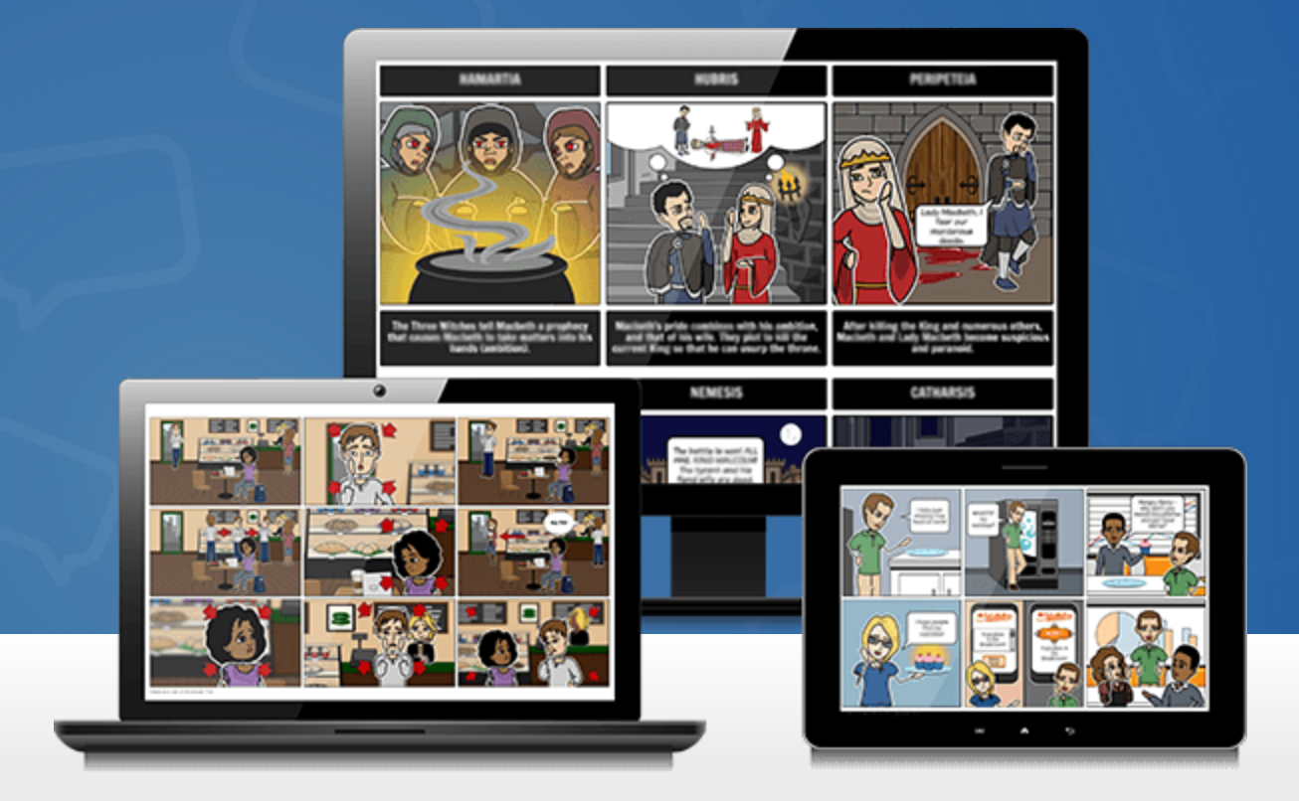
- It is time intensive and open ended – perfect for some gifted kids.
- They do not have accounts, so as the student finishes the scenes, the SNIPPING TOOL is used to copy and save the images. We save to the network drive.
- Some students can open a WORD document and paste into the document directly.

Symbaloo
- Symbaloo is an organized way to represent websites. It’s likek our Launchpad MyPage tha the district pays money for, but Symbaloo is a nicer way for kids to create their own set of bookmarks.
- https://www.symbaloo.com/home/mix/13eOcMZU9A

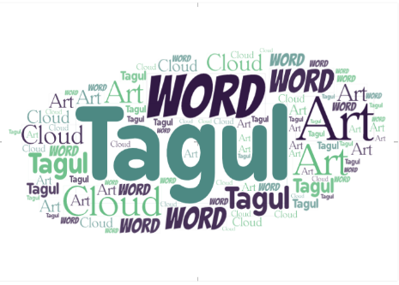
Tagul Word Art Creator
- Tagul is a word art creator that allows for shapes, animiations, and colors. It’s better than Wordle.
- https://wordart.com/create

Timeliner
- Timeline is an app on student machines and Teacher computers.
- Students do not need a special app or program to create time lines, but they can create them in Microsoft Excel.

Tinkercad
- 3D creation software. Not just for 3D printing. This can also 3D animate whole worlds, models of all sorts of things (historical, buildings, architecture, automobiles, products, code to make repetition in designs). This is a great way to have students create STEM designs – to use the iterative process duplicate and create new iterations.
- Tinkercad has many tutorials, projects, project ideas, and design challenges that come out quarterly.
- 2nd – 5th graders have logins created by me. Mr. Balaun’s students have logins under a different format. My student logins look like this: s91234567firstname3. The pattern is s their lunch number beginning with 9 then their first name then their grade. Their password is the same for the network… dekalb02, dekalb03, dekalb04, or dekalb05.

Turing Tumble
- https://www.youtube.com/watch?v=3r0P3CSYI-U
- The Turing Tumbler takes coding to the most basic, mechanical - physical switch level. Kids have many adventures to work through to solve the marble coding puzzles. The handbook is written in graphic novel format, and the 60 puzzles start deceptively simple and get much harder quickly.
- It is LOUD and will attract attention when running the simulations if you’re using a real Tumbler. There are online simulators too.
- There is an education forum for teachers.
- https://www.turingtumble.com/edu/
- I did a full evaluation here on my blog, 7/5/2018 at http://www.industriousteacher.com/blog
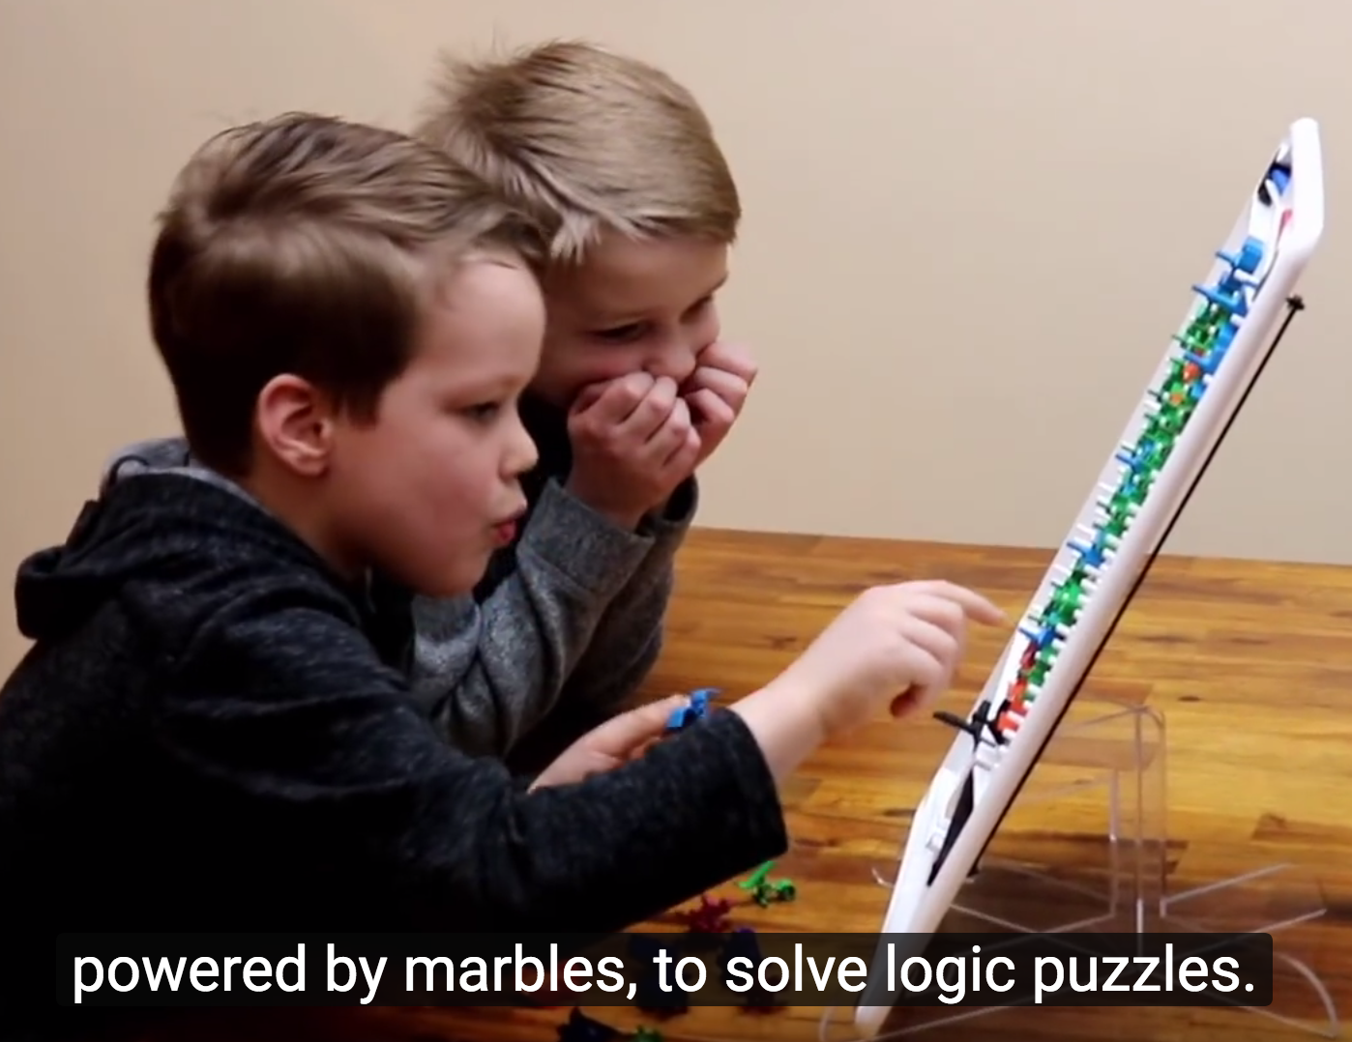

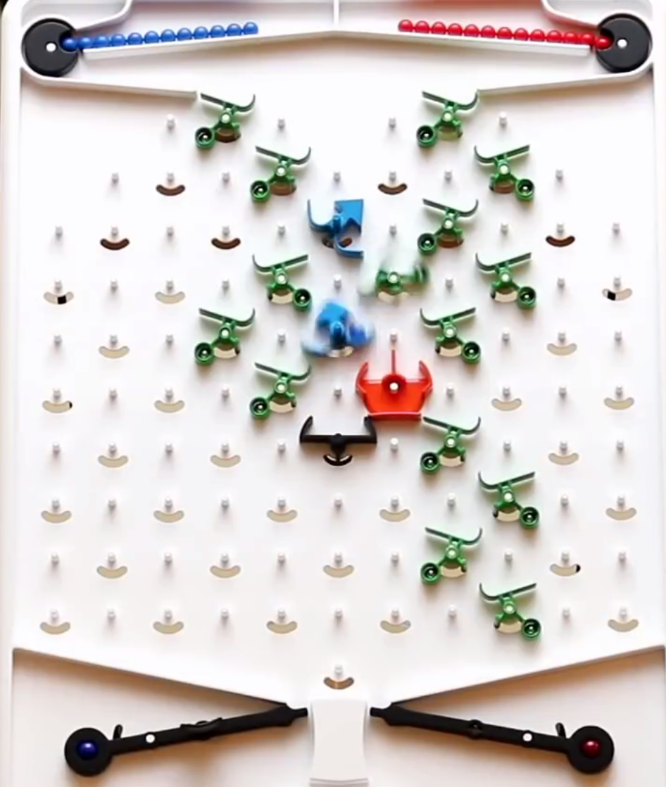
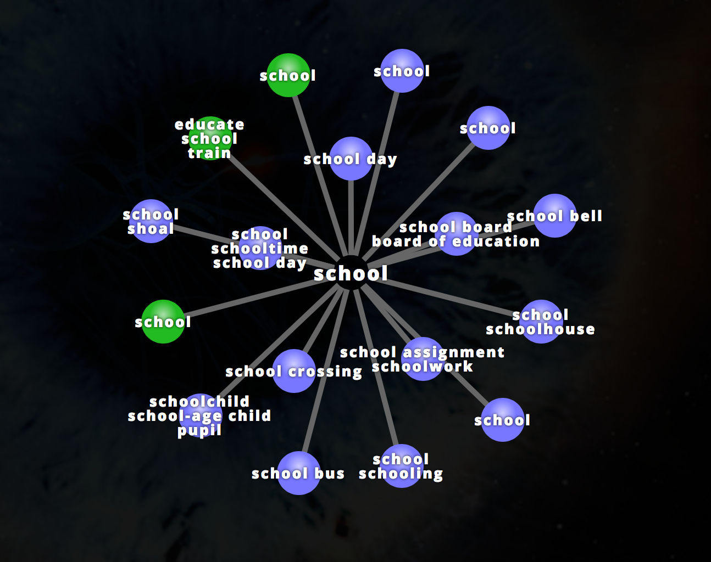

Visuwords
This is one of my favorite vocabulary programs online. It turns all the links into word-webs relative to each other….the legend/Key is really detailed. https://visuwords.com/school

Website Analysis
- Website analysis was actually my thesis project for undergraduate at Florida State.
- I created a rubric with witch to analyze and rank websites I liked.
- This would be a great activity for gifted students. It’s open ended, interest based, and allows movement up the Bloom’s Taxonomy.
- Add in collaboration, and Google Sheets or Google Docs, and the kids are doing something they previously could not have done without technology.

Website Creating
- I suggest the kids start with a Weebly free website. It’s super easy and fun. But it is public. Make sure the parent knows the child is creating an individual account if you want to go that route. Under 13 year old kids have to be monitored by an adult (parent and teacher).
- Wix is another free website creation tool.
- There is a way to integrate (embed code) Sway into webpages in both Weebly and Wix.

Wordle and Tagul
- www.wordle.net (requires a one time download) becomes offline at that point.
- Tagul https://wordart.com/create
- You don’t always have to print, especially color print full size sheets of paper. These can be added to the student’s webpage portfolio.
- This is an example of Tagul work

YouTube & Google
- Google Searches for YouTube tutorials are a great resources for figuring out how to do certain things in a variety of programs and technologies. When anyone asks me how to do something and I don’t know myself, I Google It. I type in the question in real words, “In Excel, how do I copy the first 5 letters of a name?” The result will be a how to page or a list of YouTube tutorials.
- This requires monitoring, but you can put age and topic appropriate YouTube tutorials on your Verge Pages. I would so a YouTube tutorial to the class of youngers. There are so many tutorials out there.
- Create your own How-To videos. Have the kids do it.

