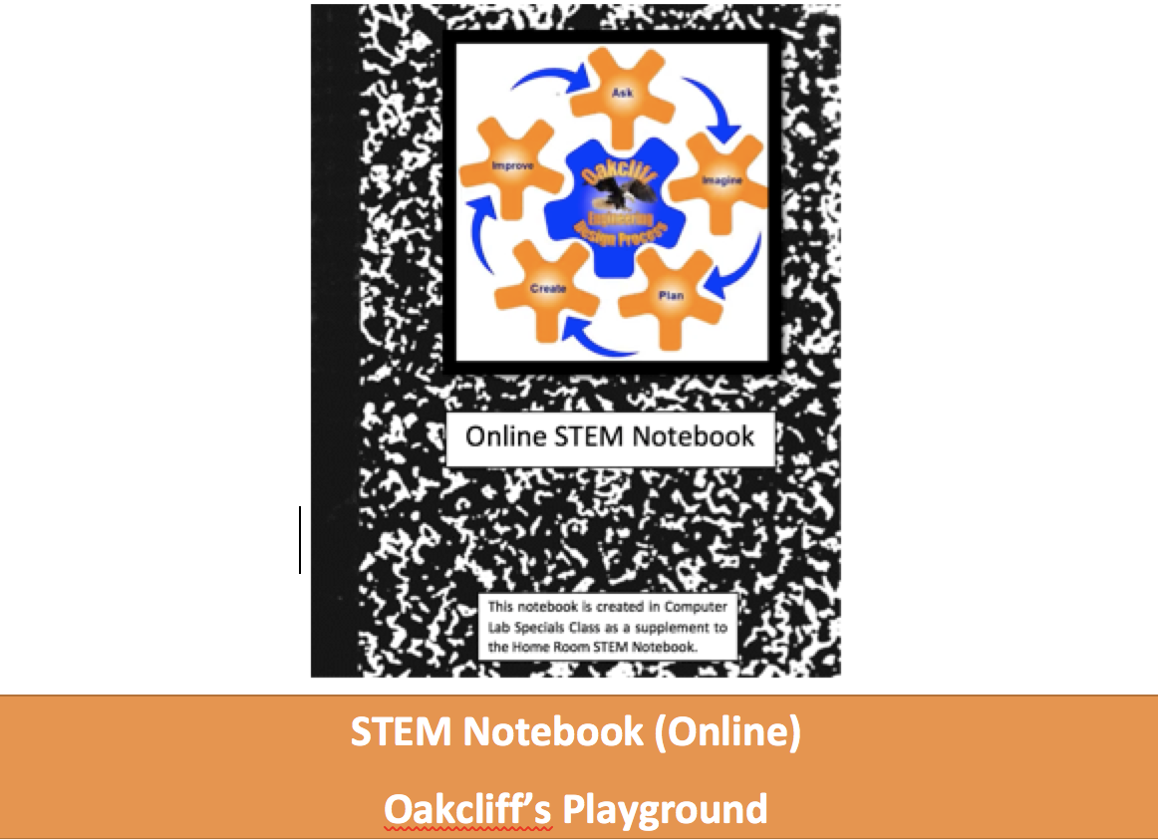
Student 1 and Student 2
Home Room: Teacher’s Name
Grade: 5th
School Year: 2018 – 2019

Table of Contents
Note: To update the table, RIGHT CLICK, Left Click “UPDATE FIELD”, then “Update entire table”.
Table of Contents
Team Member(s): 2
Description of the Problem & Team’s Role: 2
ASK & CONSTRAINTS: 2
Class Notes 4
Background Research 4
IMAGINE: 5
DESIGN: 5
CREATE: 5
IMPROVE: 5
GROUP SELF EVALUATION: 6

Team Member(s):
- Team member #1: Name Type BLUE
- Team member #2: Name Type GREEN
- Team member #3: Name Type Purple. Delete Row 3 of no 3rd member.

Description of the Problem & Team’s Role:
Our team’s Role /Job Description is designer.
STEM Careers
- Landscape Engineer (Link to Career)
- Landscape Architect: (Link to Career)
- All Landscaping Career: Job Options and Requirements (Link to site)

Our team is being asked to solve the following problem(s): Design a playground area for Oakcliff’s new Play Space that includes equipment, soccer fields, and other desired play space features. The percentage of coverage of each of these areas, needs to match the survey results from the 5th grade.

ASK & CONSTRAINTS:
Our team being asked to design a playground area for Oakcliff’s new play space. You and your STEM Partner will use the STEM Engineering Design Process to research and design a new play space for our upper grade field.
ASK: Our school's roof renovation, the construction crew destroyed our upper grades playground field. We are going to get a new play space. The PTA and your principal have asked 5th grade to design a "perfect for you" play space for the upper grades playground field area. For now, this is only an "ask, imagine, design" task.
Task Constraints:
- You and your STEM partner will be a STEM TEAM for the duration of this project. You will work collaboratively and cooperatively to research, and design a play space. The percentage, fraction, or decimal of the space used for this new design is based off of an aerial map of the space with an overlay grid. Each Lesson will have its own TASK CONSTRAINTS.
- Lesson 1: One member of your STEM TEAM will download the Online STEM Notebook, and SHARE it with the other team members. All STEM Teams will survey your classmates to see the preferred play activity and do the math representation. Together with the teacher, All STEM TEAMs will create a table of the results. Independently your STEM TEAM will create several graphs, or charts and pick the most convincing ones for your final presentation in Lesson 3.
- Lesson 2: You will then research play equipment and play structures that match the needs and wishes of the class. Research will be mostly pictures with captions that your STEM TEAM write.
  - You may use Snipping Tool to copy and paste pictures you find on various research sites.
  - You may use the Bing Search for Online Images and insert the pictures directly into your Online STEM Notebook.
  - You will need to know the measurements (size) the equipment needs for safe operation. You will also decide the space for one or more soccer fields, and the goals. You may add picnic tables, bleachers, or other equipment so long as you can explain the use of space.
- Lesson 3 and 4: Your STEM TEAM will create a drawing on a grid you create in Microsoft Excel Online that matches the aerial picture with the grid overlay. Your aerial layout map will have a key or legend. You will support your mathematical calculations using Microsoft Excel Online as a calculating tool. Your teacher will help you with the formulas for calculating percentages, fractions, and/or percents.
- Lesson 5: If your STEM Notebook is not presentable, you will need to Edit it so that it is presentable, or copy and paste the most persuasive parts of your STEM Notebook into a PowerPoint or a Sway presentation. Things you need to have in your final presentation include:
  - The Original Survey Data,
  - 1 - 2 Graphs that make that data understandable,
  - Your Excel map drawing of your play space design with a key or legend.
  - At least 4 Pictures of play equipment, with a caption that tells what it is used for.
  - A calculation of the square footage percentage, fraction, or decimal that your design will take up.
  - The comparison of your design versus the original survey data.

Class Notes
(Probably from the teacher):
This is the section where you will insert any information the teacher gives to you. This could be website/URL/Addresses, pictures, videos, drawings, or notes.
Playground Equipment Resources:
Browse these Playground manufacturers. Dream Big. There is NO concern about Money at this point. DREAM BIG!!! What makes your dream playground?
- https://www.bigtoys.com/ These play structures are designed by age.
- https://www.playgroundequipment.com/products/commercial-playgrounds/ This site has a planner.
- https://www.gametime.com/ This site has a planner.
- https://www.miracle-recreation.com/products/ This site has a planner.
- https://www.playlsi.com/ This site has playgrounds for areas by square feet.
- https://www.aaastateofplay.com/ages-5-12-years-play-structures/ This gives a “use zone.”
- https://www.kompan.us/play This is unique play equipment.

Soccer goals
- https://www.soccer.com/shop/products/equipment/goals This page has a lot of sizes of soccer goals.
- https://www.soccer.com/shop/details/kwik-goal-afr-2-rebounder_A2B1602 This is an idea to have out some “rebounder” goals for kids who want to kick soccer balls, just not in the game.
- https://www.soccer.com/shop/details/pevo-small-soccer-goal-4-x-6_ARC46 4 x 6 small sided goal.
- https://www.soccer.com/shop/details/pugg-pop-up-goals-6_A7844 PUGG Popup goals
- https://www.soccerpro.com/product-category/soccer-equipment/field-equipment/ variety of sizes of goals.
- Goals and Field Sizes: https://www.soccer.com/guide/how-to-pick-the-right-soccer-goal Use this page to decide the size of your 1, 2, 3, or 4 fields. Get goals that are sized appropriately for the field size.
---

Background Research
(Probably that your team finds online)
This is the place in the Online STEM Notebook, where you will add your screen shots of images you find helpful to your project.
---

IMAGINE:
Insert typed notes, or drawings of what I imagine might meet the criteria and goals of the original ASK. All drawings should have labels on them, or a written or spoken description.
---

DESIGN:
Our team picks one of the IMAGINED Ideas as the one we will begin creating. Copy and Paste that idea here. Think through it and make adjustments before and during the team’s creation.
---

CREATE:
For this project, there is no CREATE. You are just Designing the plan, and doing the math calculations.
_____

IMPROVE:
What 2-3 things would your group do to make ITERATION ONE match more of the goals, meet more constraints, etc. If your project worked, met all the constraints, and is overall pleasing to your group, think about 2-3 ways that you could go through the manufacturing or creative process “faster using fewer steps” which is known as “increasing efficiency.”
---

GROUP SELF EVALUATION:
Ask your teammates to reflect on how you all worked together. This chart is adapted from the paper version created by Ms. Nancy Balaun. This is modified for online use.
5th Grade Rubric for STEM Activities in Computer Lab Directions: For each section, Color the box your group gives itself for each row. Type in your score (4, 3, 2, or 1) to the left under Our Rating. Add each Row for your total rating.

 | 4 - Distinguished | 3 - Proficient | 2 - Developing | 1- Beginning
Communication and Collaboration | We worked really well together. We shared all of the work. We listened well to each other and worked to contribute ideas to the whole. Our final presentation is persuasive, accurate, and well organized. | We worked well together sharing MOST of the work. We listened to each other MOSTLY and worked to contribute ideas to the whole. Our final presentation is accurate, and well organized, but may not be persuasive. | We barely worked together. We did not share the work, or listen to each other well. Our final presentation is not persuasive, inaccurate, and poorly organized. | We did not work as a team. We did not communicate or collaborate much. We do not have a final presentation completed.
Innovation and Responsibility | We all took part in this project from start to finish coming up with and sharing ideas, fully explaining our reasoning, analyzing the math, and writing descriptive, persuasive, sentences. | We all took part MOSTLY in this project . We came up with ideas and shared them. We MOSTLY explained our reasoning, analyzed the math, and wrote descriptive, persuasive, sentences. | One some of us took part in this project . We had trouble sharing our ideas. We did not explain our math, or graphs, and we wrote few sentences. | We struggled to work together. We did not share our ideas, did not do our math, or graphs, and we wrote very few sentences.
Critical Thinking and Problem Solving | We all actively participated in brainstorming many different ideas, coming up with a detailed and labeled plan we agreed. We all contributed to the math, graphs, and decisions. | We participated in some brainstorming, some labeling, and some math and graphs. | Only one of us brainstormed and did , some labeling, and some math and graphs. | We participated in some brainstorming, some labeling, and some math and graphs.
Documentation | We all kept up with our Interactive Notebooks, making detailed notes, citations for pictures, and typed descriptions of what we did and why. | We all mostly kept up with our Interactive Notebooks, but did not do all of the things in the “4” column. | One of us kept up with our Interactive Notebooks. | We did not keep up our Interactive Notebooks.
Total Score for self assessment

