Implementing Sheltered Instruction Observation Protocol (SIOP) and Specially Designed Academic Instruction in English (SDAIE)
By
Heather M. Miller
In partial fulfillment of course requirements
of Sessions 8-10 for
ESOL Course Instructional Strategies

Table of Contents
Table of Contents 1
Workbook Assignment: 3
Companion Website 4
Workbook Answer 5
Reflection on Lesson Implementation 7
Guide to Appendices 8
Appendix A - The Lesson Plan 10
The SIOP LESSON PLAN Design Oakcliff's New Play Space - Playgrounds, Soccer Fields, and Blacktop: A STEM Unit Plan Integrating SIOP Language Goals 10
Purpose of the Unit Plan 10
Lesson 1 11
Lesson 2 12
Lessons 3-4 14
Lesson 5 16
Background Information on the STEM Project and SIOP Lesson 17
Academic Citations 18
Appendix B - The Student’s Unit Lesson Plan Overview, Vocabulary, and Resource Page 19
The Student’s Unit Lesson Plan Overview, Vocabulary, and Resource Page Design Oakcliff's New Play Space - Playgrounds, Soccer Fields, and Blacktop: A STEM Unit Plan Integrating SIOP Language Goals 19
Appendix C - The Lesson 1 Page 23
The SIOP LESSON PLAN #1: Design Oakcliff's New Play Space - Playgrounds, Soccer Fields, and Blacktop: A STEM Unit Plan Integrating SIOP Language Goals 23
Appendix D - The Lesson 2 Page 24
The SIOP LESSON PLAN #2: formatted for the ESOL Course 5th Grade Will Design Oakcliff's New Play Space Including Playgrounds, Soccer Fields, and Blacktop: A STEM Unit Plan Integrating SIOP Language Goals 24
Appendix E - The Lesson 3-4 Page 27
The SIOP LESSON PLAN #3 and #4: formatted for the ESOL Course 5th Grade Will Design Oakcliff's New Play Space Including Playgrounds, Soccer Fields, and Blacktop: A STEM Unit Plan Integrating SIOP Language Goals 27
Appendix F - The Lesson 5 Page 29
The SIOP LESSON PLAN #5: formatted for the ESOL Course 5th Grade Will Design Oakcliff's New Play Space Including Playgrounds, Soccer Fields, and Blacktop: A STEM Unit Plan Integrating SIOP Language Goals 29
Appendix G - The Online STEM Notebook 31

Workbook Assignment:
Developing a Sheltered Instruction Unit Plan
Choose a grade level and content area that you are working with now or plan to work with in the future and create a four-five-lesson unit for a class that includes ELLs.

Each lesson must include:

● Content and language objectives for each lesson (sheltered instruction), correlated to Georgia Performance Standards
http://www.georgiastandards.org and WIDA ELP Standards http://www.wida.us/standards/elp.aspx
● Strategies and practices to build study skills and to increase language use, interaction, and comprehensibility.
● Modifications for ELLs at varying proficiency levels (pre-production, early production, speech emergence, intermediate fluency)

Implement at least two of the lessons within the timeframe of this course. If possible, ask a certified ESOL teacher or another colleague to observe the lessons or videotape yourself and review the tapes. Then reflect on the lesson implementation and this teacher’s feedback. Consider the students’ experience of this lesson. Suggest revisions of these lessons for later use.

This assignment is being given early in the course to allow adequate time for completion; it should be developed as the course progresses to incorporate knowledge and strategies presented in each session. This Workbook counts as two of the required three Workbooks and is worth 50 points (rather than the usual 25 points). (TESOL/NCATE 3; InTASC 7; ISTE 6) Due by the end of Session
10.

Companion Website
There is a companion website to this written document located at
http://www.industriousteacher.com/5th.html .

Should I ever move the top level webpage, there are two divisions as well.

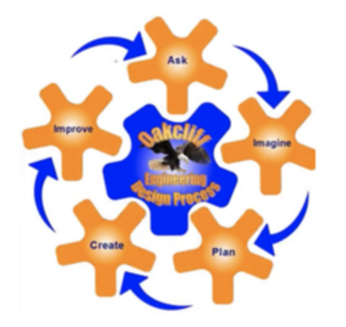
Website for students, “The Student’s Unit Lesson Plan Overview, Vocabulary, and Resource Page – Design Oakcliff's New Play Space - Playgrounds, Soccer Fields, and Blacktop: A STEM Unit Plan Integrating SIOP Language Goals” located at http://www.industriousteacher.com/5th-siop-vocab.html

Website for adults and teachers, “The SIOP LESSON PLAN
Design Oakcliff's New Play Space - Playgrounds, Soccer Fields, and Blacktop: A STEM Unit Plan Integrating SIOP Language Goals” located at http://www.industriousteacher.com/5th-siop-lp-esol-class.html
”

Workbook Answer
The students are 5th grade computer lab specials students. There are students who are identified as being Level 1 Entering, Level 2 Emerging, Level 3 Developing, Level 4 Expanding and Level 5 Bridging, and there are those students who have tested out of ESOL support. There are less than 15% of my students who are first language English speakers.

Content : Computer Lab Specials STEM Unit

Languages spoken: 85% ESOL. Majority Spanish. Some Chinese, Korean, and Bengal. Less than 15% are first language English Speakers.

Other relevant information: We are a STEM Theme School. In my computer lab specials class, I try to incorporate a STEM Unit each semester that takes multiple classes, includes research, collaboration, and a build or final design. For this unit, I have included the use of many skills we have been working on individually in class over this school year. Also in my class, I am working towards a blended classroom for differentiation and created the student website to that end. The audio supports and video supports are for my ESOL students who might have trouble reading academic content. Some of it is verbal instruction, and some of it is reading what I wrote on the webpage.

Pre-/post-assessment of content and language: As a pre assessment, every student in ESOL courses has taken ACCESS Tests for this school year but the results are not in. With over 120 5th grade students, I take the position that I am probably teaching “Intro to Computers” to a majority of ESOL students. Because this is a specials class, we do not do formal pre and post assessments, else we would literally have no classes left to teach. The class is exploratory in nature and graded pass/fail. We try to get to the culmination of a unit, but often, due to computer lab access being removed, every group or individual rarely gets to present our final projects in class. If we get one or two presented I consider this a success. I know we are not supposed to make assumptions about our students, but much of what I teach is new content to the majority of the ESOL students.

How your unit will support your ELLs’ needs? I have created a website to go along with this unit. http://www.industriousteacher.com/5th-siop-vocab.html . There are individual lesson web pages to support the unit, and help keep the students on track. They can look ahead, explore resources, and repeat anything on the website as often and as much as need be to facilitate learning the language and the math content. I expect it might take more than 5 days for the 5 lessons, since we are in the middle of testing almost always, spring break is coming soon, and we often have some school-wide event that causes us to miss at least one day of 5th grade specials each term. When teaching, I always assume we are starting at a zero knowledge point, because of language, poverty, access, and school-specific tasks. The kids might have seen Microsoft Office Suite programs, but they have probably not used the programs like I am showing them how to use the programs because I integrate their usage. Rarely will I have them do a substitution activity like type your journal that you already handwrote. I will have them type a journal from the air, and add pictures. Or I’ll have them start with a visual prompt and tell me everything they see. Then Compare and contrast it to a second picture. Or I’ll have them create a graph and write about it, descriptively or persuasively. Usually I focus on the visual story telling to be persuasive or informative. Thus, I use a lot of visuals, hands on demonstrations, and spiral instruction to the group. I use a lot of “tell your neighbor” or “Ask your neighbor” strategies when i am teaching new words, or phrases, or skills. I also allow “helpers” who I have checked are doing the skill properly, and those helpers talk to the other kids in whatever language is comfortable to them to get the skill done. Then I will go around the room to each individual student’s computer and see where they are, and give them a boost if they need help, or offer them an enrichment activity if they already mastered the skill. I need to use word walls more adequately. I am working towards making the lessons online, where the kids can repeat my lessons as many times as they need to. This is one reason I put this unit plan on a website. I really want to try to give the student a chance to use the accessibility tools on their computer to read aloud text to them. I am anxious to give this a try.

The lessons included create a logical sequence and development of content knowledge, skills, and language development because this is a cumulative unit based on ISTE standards (technology standards), real world problem solving STEM Units, and 5th grade math standards. The individual computer tasks I am having them do are skills we have worked on individually over the course of this school year. This unit is a STEM Unit based on a real world problem caused by our roof construction contractors ruining our upper grades play area. The students are used to STEM Engineering Design Process from their grade level classes over the last two years. Lesson 1 calls for a survey and chart making which is a skill students have done in homeroom math classes since second grade. Also in Lesson 1, students are to download and share a file using OneDrive, which the students have done already this year. This will be the second time we are using the Online STEM Notebook (Downloadable in Lesson 1 of the website lesson). I have revamped and streamlined the Online STEM Notebook based on feedback I received from the first use in first semester. Lesson 2 is online research and screen shots, with copy and pasting. These are skills the students have been doing for the majority of the school year. Lesson 3 and 4 call for the finding of area, which SHOULD be a math review for them since they have seen area in third, fourth, and fifth grades. We have used Microsoft PAINT, and Microsoft EXCEL several times this year and last year. Excel will be the brand new content for some students. Since I am having them find area using a grid, even if their math skills are weaker, they can still count squares. Further, I am differentiating here because some students will prefer to calculate by the grid overlay, and others will prefer to try the Microsoft Excel method of grid design. Once these grids are done in either place, students can type or talk to justify their choices, and math calculations. Any language needed to justify the size of their choices for playground equipment, soccer fields, and the blacktop can be explained using mathematical terms of art, or visual words that are closer to social language. Because I am having the students compare percentages, I am going to show them how to calculate percentages, and fractions in Microsoft Excel. This is the new content for the lesson. I want them to see it done, and how they too can use Excel to calculate their math. When they compare and see their percentages are off based on the original desired percentages, I will show them how quickly it is that Microsoft Excel can recalculate with minor input changes. Lesson 5, students are asked to present their projects. Because I am telling them the presentation is coming, I will also remind them that their Online STEM notebook counts as a presentation tool, so it is a good idea to keep it neat. If they so choose, they can also use Microsoft PowerPoint or Microsoft Sway to be more succinct in their final presentation.

The Online STEM Notebook is the main graphic organizer used in this Unit Plan. The student can modify it electronically, and because the document is shared, both or all three of the STEM Team can add and make additions and changes to it in real time. The Website I created to support students is the Task organizer with blended learning opportunities embedded for differentiation, enrichment, and remediation if needed.

I will use digital learning tools that maximize learning because I am a technology teacher. I integrate many software programs above, desktop computers, online drives, ChromeBooks, and blended learning. I endeavor to make the class a blended class and foster collaboration in this real world STEM project. I also endeavor to make the project one which is previously inconceivable without technology. (SAMR Model).

This project addresses (1) oral language development, (2) transitions to print, (3) reading and writing for purpose, and (4) supporting ELLs in content areas. (1) This project supports oral language development because it is a STEM Team project. The STEM Teams are going to engage in verbal communication with each other to decide how to split the workload, plans of attack, and decisions on why this choice is better than that choice. Further, as the students narrow their choices for the project, they will have to justify to each other why the narrowing choices make more sense to use than the discarded choices. (2) This project supports transitions to print because there needs to be captions written for each picture. Persuasive sentences are required to appear in the final presentation, either in spoken form (Entering and Emerging) that is converted by the partner into print, or directly to print, copied or typed by the Emerging, Developing, Expanding, Bridging, or fluent ELL student. (3) This project supports reading and writing for purpose because it is a real world problem and the students are being asked to solve it using independent research on the Internet. This is open-ended research, culled from the real world of companies that are attempting to sell products with their own profits as motive. Students will be handed a list of websites to start, but as Internet searches often do students may go far and wide and must evaluate the text they are reading as to the time spent and quality of what they are looking for gained. (4) Finally, this project supports supporting ELLs in content areas of math. While area is already a well-covered topic by this time in fifth grade, it is a difficult subject for many. The more real world, hands on practice the better. Even for those ELL students who learned area sufficiently, the Microsoft Excel part of the Unit Plan should provide enough enrichment opportunity, if interested.

Reflection on Lesson Implementation
reflect on the lesson implementation and this teacher’s feedback. Consider the students’ experience of this lesson. Suggest revisions of these lessons for later use.

I have introduced this Unit to three of my four 5th grade classes (Class A, B, and C; D class has not met yet). The fourth 5th grade class was diverted to a school-wide assembly and is a day behind the other classes. Each of the three classes were varying levels of excited about the project. Class A liked the idea of the unit. They were excited to use the aerial pictures of the playground area because they had been outside at recess when our school’s STEM teacher was testing out our school’s drone. Class B was less enthusiastic about the project, but that is typical of this class, except for a few students who seemed to be excited about the project of leaving a “legacy” playground, like a class gift to the school. Class C was enthusiastic about the play equipment when I told them there was no budget, then corrected it to, “unlimited budget” for this project and that ropes, ziplines, jungle-rope, swings, multiple soccer fields, etc. could be added.

All three classes so far have filled out the general percentage survey, and Class C has completed an “Answer Garden” to describe the playground elements they are excited to play on or provide at our school.

I have one more introduction to Class D, and I expect similar results to Class C, as they are the two most similar classes.

In the future, I need to have an audio or video introduction. There were so many questions so fast, that each class ended up in wildly different directions. I got the main points across but in one class I ran over by two minutes. This wreaks havoc in an elementary school because it throws off a ripple of effected things: lunch, bathrooms, recess, etc. To avoid this, a short introductory video would ensure that all the important topics were covered and then the barrage of questions can begin. Or, better yet, having those questions presented in a “choose your own adventure” type path of explainer videos would allow the fast groups to work faster and the slower groups to ask for teacher help, which is at a premium.

Guide to Appendices
To view the front page of the website created in support of this Unit Lesson Plan, visit http://www.industriousteacher.com/5th.html

See Appendix A for a reproduction of the Lesson Plan web page or visit it at http://www.industriousteacher.com/5th-siop-lp-esol-class.html

See Appendix B for a reproduction of the Student’s Unit Lesson Plan Overview, Vocabulary, and Resource Page or visit it at http://www.industriousteacher.com/5th-siop-vocab.html

See Appendix C for a reproduction of the Lesson 1 Page or visit it at http://www.industriousteacher.com/5th-siop-l1.html

See Appendix D for a reproduction of the Lesson 2 Page or visit it at http://www.industriousteacher.com/5th-siop-l2.html

See Appendix E for a reproduction of the Lesson 3-4 Page or visit it at http://www.industriousteacher.com/5th-siop-l34.html

See Appendix F for a reproduction of the Lesson 5 Page or visit it at http://www.industriousteacher.com/5th-siop-l5.html

Appendix A - The Lesson Plan

The SIOP LESSON PLAN
Design Oakcliff's New Play Space - Playgrounds, Soccer Fields, and Blacktop: A STEM Unit Plan Integrating SIOP Language Goals

Purpose of the Unit Plan
To include SIOP in a Computer Lab Lesson Plan using Microsoft Excel Online, Microsoft Sway Online, TinkerCAD, Snipping Tool, and student chosen research tools to complete a STEM Design and Virtual Build.
Unit Standards
CTAE - Technology Content Standards: Computer Lab uses International Society for Technology in Education (ISTE) standards for Students. This SIOP integrated unit will focus on:
ISTE 3 Knowledge Constructor - "Students critically curate a variety of resources using digital tools to construct knowledge, produce creative artifacts and make meaningful learning experiences for themselves and others.
- ISTE 3a. Students plan and employ effective research strategies to locate information and other resources for their intellectual or creative pursuits.
- ISTE 3c. Students curate information from digital resources using a variety of tools and methods to create collections of artifacts that demonstrate meaningful connections or conclusions.
- ISTE 3d. Students build knowledge by actively exploring real-world issues and problems, developing ideas and theories and pursuing answers and solutions.
ISTE 4 Innovative Designer - "Students use a variety of technologies within a design process to identify and solve problems by creating new, useful or imaginative solutions" (Citation: https://www.iste.org/standards/for-students).
- ISTE 4a. Students know and use a deliberate design process for generating ideas, testing theories, creating innovative artifacts or solving authentic problems.
- ISTE 4b. Students select and use digital tools to plan and manage a design process that considers design constraints and calculated risks.
- ISTE 4c. Students develop, test and refine prototypes as part of a cyclical design process.
- ISTE 4d. Students exhibit a tolerance for ambiguity, perseverance and the capacity to work with open-ended problems.

Math Standards (link):www.georgiastandards.org/Georgia-Standards/Frameworks/5th-Math-Curriculum-Map.pdf
Adding, Subtracting, Multiplying, and Dividing Fractions MGSE.5.NF.6 Solve real world problems involving multiplication of fractions and mixed numbers, e.g., by using visual fraction models or equations to represent the problem
WIDA Standards
https://wida.wisc.edu/teach/standards/eld
Standard 1 – Social and Instructional Language
English language learners communicate for social and instructional purposes within the school setting.
Standard 3 – Language of Mathematics
English language learners communicate information, ideas and concepts necessary for academic success in the content area of mathematics.

Lesson 1
Lesson Objectives
Content Objective:
ISTE 3a, 3c, 3d, 4a, 4b, 4d.
- SWBAT recall the STEM EDP and the Online STEM Notebook,
- SWBAT understand the Ask, Discuss and Plan stages, and begin working with their STEM Team, including sharing the online file.
Language Objective:
- SWBAT discuss with the STEM partner the elements of play for the play space, and jointly develop an internet resource based research plan for pictures of play equipment, play structures, field sizes.
Interactive Activity
Opinion Continuum. Students in class will stand in corners according to their favorite recess activity. Students will count classmates in each group.
Students will create a graph in Excel in later lessons. Student created design should reflect student's preferences in percentages, fractions, or decimals.
Students will read and discuss (think-pair-share) with the class what is being asked of them at the ASK stage of the EDP.
Students will work with thier STEM partner to create the shared Online STEM Notebook (Microsoft Word Online) to prepare a place to organize and collect picture ideas of the school's existing space, ideas for play structures, and field spaces.
Group Configurations / Composition
Students self-selected STEM groups of two or three students in January. The STEM groups sit next to their partner in the computer lab for easy think-pair-share, and "repeat to your neighbor" tasks. At least 85% of the student body is ELL or former ELL student, so almost all groups have at least one ELL.
Academic Language in Activity
Select, count, compare, STEM Engineering Design Process, ask, imagine, plan, create, iteration, cycle, Excel, Google Chrome, Snipping Tool, switch programs, search bar, screenshot, arial, image, photograph, fraction, percent, decimal, graph, overlay, grid, CTRL+C (copy), CTRL+V (paste), save, save as, insert
Ideas for Academic Interaction
Possible sentence frames for different levels of ELL students.
- I like to play...
- I prefer to play...
- At recess, I wish I could play on...
- In PE, I want to play ___
- What is the count of the preferred play in this class?
- I think the neighborhood people come to our play space to play ___.
- I like to play ___ because ____.
- Your idea is fun because ....
- I might play ___ if ____ were available.
- Let's research ___ first and ____ next.
- I want my school's play space to include playground equipment, fields, and ____.
- I want soccer goals to be movable or stuck in the ground because _____.
Integrated WIDA Strands
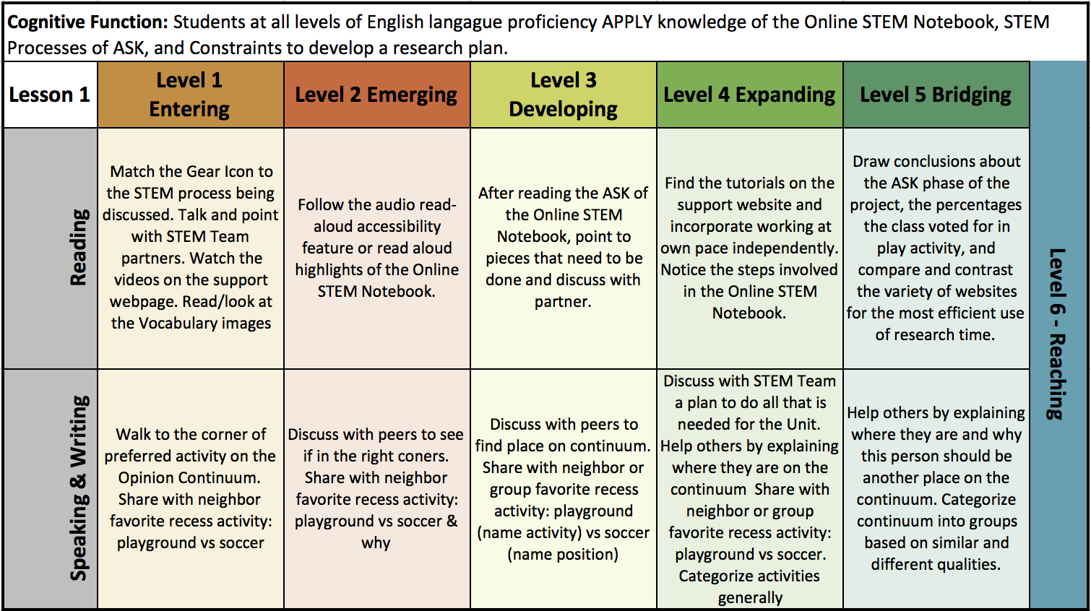

Lesson 2
Lesson Objectives
Content Objective:
ISTE 3a, 3c, 3d, 4a, 4b, 4d.
- SWBAT research ideas in pictures and words using the online STEM Notebok to store images, ideas, and math of fractions, percentages, or decimals.
Language Objective:
- SWBAT search online exploring play structures and equipment focusing on pictures, then the students will read the descriptions of the images they like in conversation with their partner, discussing the benefits of the structure and layout of the elements of play for the play space.
- SWBAT jointly pick the team's favorite 3 to 5 images of play equipment or structures and justify those choices with a short label of each picture.
- SWBAT discuss and then and write 1 to 2 sentences on what it is that they like about the images.
Interactive Activity
Formulate-Share-Listen-Create The teacher presents a question:
"If you could design the perfect play space for this school, what would you include for equipment, fields, blacktop markings?"
"What are the space requirements for our STEM team's selection?"
The students formulate an answer individually. Then they share their answers with their STEM partner. They listen carefully to their partner’s answer, note the similarities and differences, and they both create a new answer that incorporates the best of both ideas, typing their combined answer into their STEM Notebooks. Later they will share with the rest of the class.
Group Configurations / Composition
Students self-selected STEM groups.
Academic Language in Activity
Select, count, compare, STEM Engineering Design Process, ask, imagine, plan, create, iteration, cycle, Excel, Google Chrome, Snipping Tool, switch programs, search bar, screenshot, arial, image, photograph, fraction, percent, decimal, graph, overlay, grid, CTRL+C (copy), CTRL+V (paste), save, save as, insert
Ideas for Academic Interaction
Possible sentence frames for different levels of ELL students.
- At recess, I wish I could play ...
- In PE, I want to play ___
- I like to play ___ because ____.
- Your idea is fun because ....
- This idea is better because___
- I like this part of that idea ___but I like this part ___ better.
- I might play ___ if ____ were available.
- Let's research ___ first and ____ next.
- How can we have more soccer fields?
- How could an obstacle course be made safe?
- I want soccer goals to be movable or stuck in the ground because___.
Integrated WIDA Strands
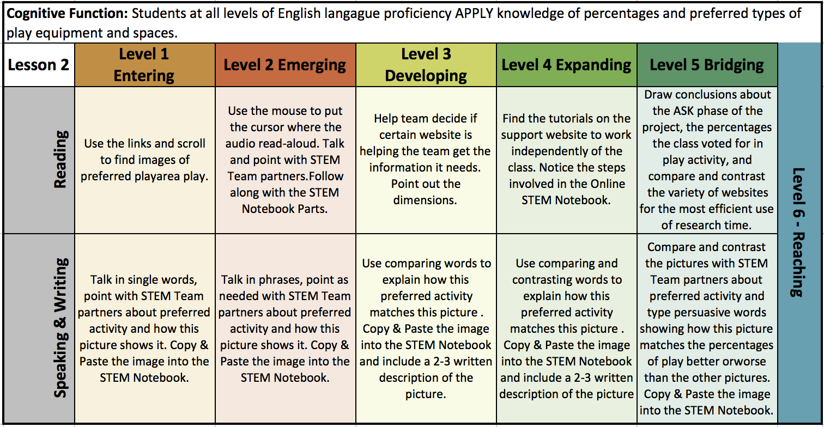

Lessons 3-4
Lesson Objectives
Content Objective:
ISTE 3a, 3c, 3d, 4a, 4b, 4c, 4d.
- SWBAT use fractions, decimals, or percents to design the playground space using MS Excel as a design grid,
- SWBAT display the math as charts and graphs using Excel as a calculation tool.
Language Objective:
- SWBAT read the descriptions of the play equipment's size and space requirements, and transfer the dimensions onto the scaled grid created in Excel, using the picture with the grid overlay for reference.
- SWBAT argue the benefits of their plan's allotment of percentage/fraction/decimal of space allotted to each play activity.
Interactive Activity
Formulate-Share-Listen-Create The teacher presents a question:
"Using the school's aerial picture with the grid overlay, how can your STEM team calculate the percentage, fraction, or decimal math to show how much space your design covers?"
The students formulate an answer individually. Then they share their answers with their STEM partner. They listen carefully to their partner’s answer, note the similarities and differences, and they both create a new answer that incorporates the best of both ideas, typing their combined answer into their STEM Notebooks. Later they will share with the rest of the class.
Group Configurations / Composition
Students self-selected STEM groups.
Academic Language in Activity
calculate, grid overlay, Select, count, compare, STEM Engineering Design Process, ask, imagine, plan, create, iteration, cycle, Excel, Google Chrome, Snipping Tool, switch programs, search bar, screenshot, arial, image, photograph, fraction, percent, decimal, graph, overlay, grid, CTRL+C (copy), CTRL+V (paste), save, save as, insert
Ideas for Academic Interaction
Possible sentence frames for different levels of ELL students.
- Where is the grid on the aerial map? Where is the grid on the Microsoft Excel? Which is easier to work with?
- Looking the aerial map of the school with the grid overlay, how can we use the grid in EXCEL to find the percentage/fraction/decimal of the total play space area that the different play areas cover?
- How should we present this math data? fractions, percentages, or decimals?
- Which is the clearest representation of the math, a bar graph, a table, a pie graph?
- How do we create a chart that turns into a graph in MS Excel?
- Which graph looks best? Why?
- How can I use Snipping Tool to collect information into my STEM Notebook?
- Does our design meet the math of the class's preferred play from day one?
Integrated WIDA Strands
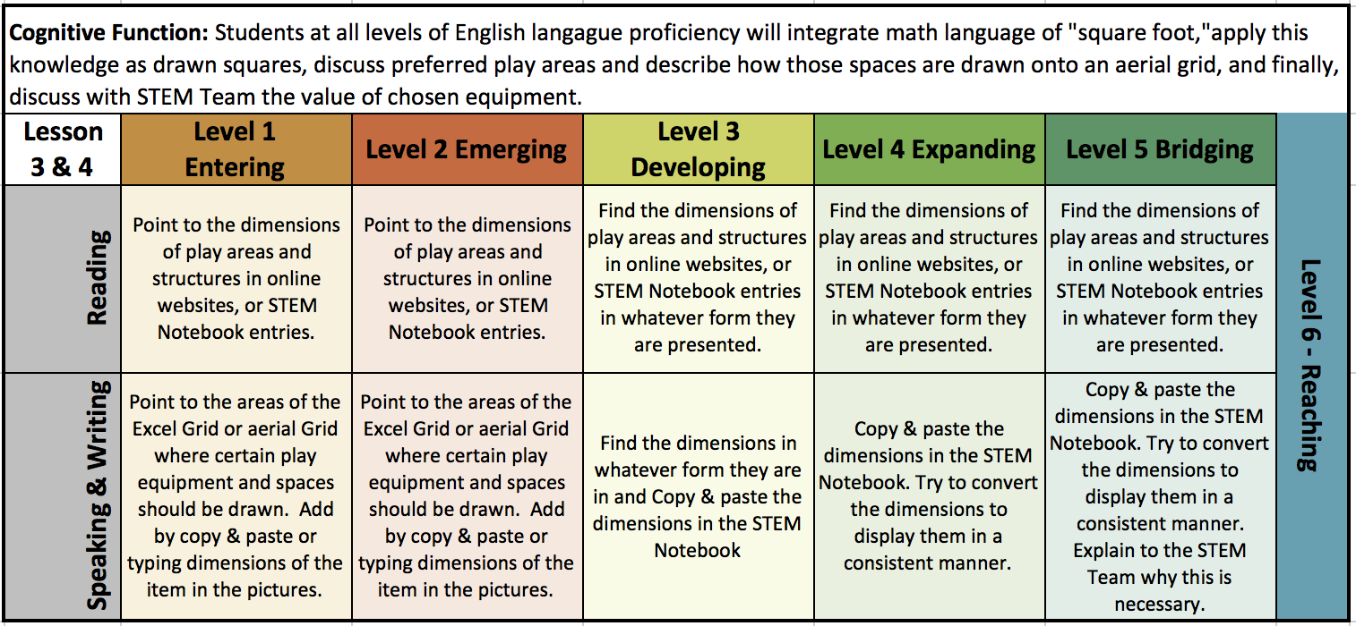

Lesson 5
Lesson Objectives
Content Objective:
ISTE 3a, 3c, 3d, 4a, 4b, 4c, 4d.
- SWBAT put your designed plan together in SWAY using photo stacks, measurements, and your grid plan or use PowerPoint with pictures.
Language Objective:
- SWBAT organize theplay structure idea pictures, grid created in Excel, and math calculations from their STEM Notebook using the website platform SWAY, or PowerPoint.
- SWBAT describe the benefits of their plan's allotment of percentage/fraction/decimal of space allotted to each play activity, comparing their math percentages to the preferred activities of the class from lesson 1.
Interactive Activity
Formulate-Share-Listen-Create The teacher presents a question:
"Should your STEM Team use teh STEM Notebook or SWAY or PowerPoint to present an organized and persuasive representation of the information in your STEM Notebook? Whichever program you decide to use, be sure to include your Excel Grid, math representations showing how much space your design covers, pictures of equipment, and the original math survey."
The students formulate an answer individually. Then they share their answers with their STEM partner. They listen carefully to their partner’s answer, note the similarities and differences, and they both create a new answer that incorporates the best of both ideas, typing their combined answer into their STEM Notebooks, SWAY, or PowerPoint. Later they will share with the rest of the class.
Group Configurations / Composition
Students self-selected STEM groups.
Academic Language in Activity
culminate, calculate, grid overlay, Select, count, compare, STEM Engineering Design Process, ask, imagine, plan, create, iteration, cycle, Excel, Google Chrome, Snipping Tool, switch programs, search bar, screenshot, arial, image, photograph, fraction, percent, decimal, graph, overlay, grid, CTRL+C (copy), CTRL+V (paste), save, save as, insert
Ideas for Academic Interaction
Possible sentence frames for different levels of ELL students.
- I prefer to use the PowerPoint because ___.
- I prefer to use the Sway because ___.
- I prefer to use the STEM Notebook because ___.
- We should include these 5 images of ___ in our presentation because ___.
- The way we presented this math data is effective because ___.
- Did we use the Snipping Tool to collect information into my STEM Notebook?
- We (did/did not) end with a persuasive argument sentence showing that our design meets the math of the class's preferred play from day one?
Integrated WIDA Strands
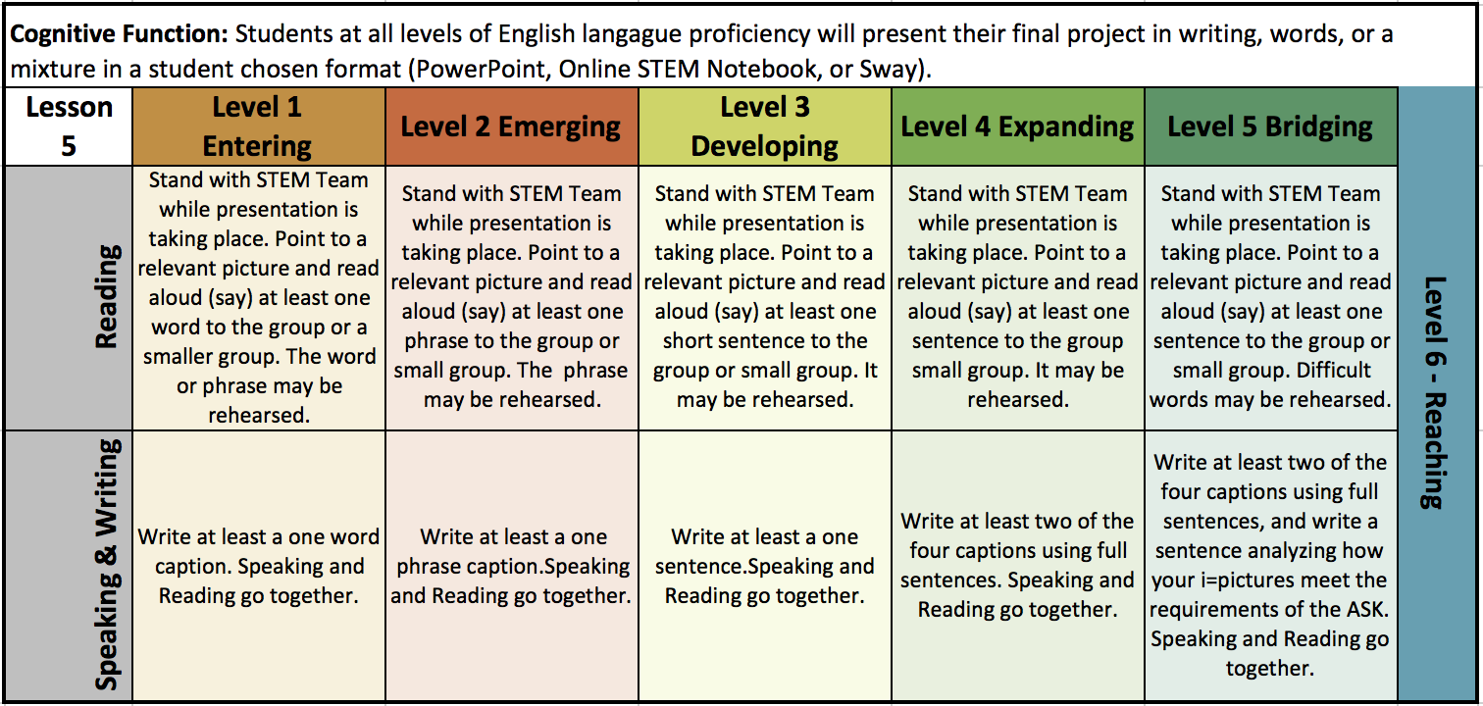

Background Information on the STEM Project and SIOP Lesson
Or school is an AdvancEd STEM Certified elementary school. We are a Dekalb County, Georgia "Choice School." Our official name is Oakcliff Traditional Theme School and our theme is STEM. Parents apply to the lottery for their kids to attend. We are Title I school with 85% or higher of our students speaking a language other than English at home. We have parent volunteer requirements, PTA membership, school uniforms, and nightly reading requirements. We also have many events that celebrate our staff and student body.
Every student attends a Computer Lab specials class once a week on a rotation with the other once-weekly specials classes, I, Heather M. Miller, am the Instructional Technology Teacher in the computer lab. I have special education license, a CTAE K-12 Engineering and Technology Certification, and an endorsement in Gifted Education.
Why was this Unit Plan created? This unit plan was created as partial fulfillment of the Dekalb County ESOL Endorsement program, February 2019 by Heather M. Miller, ESOL Endorsement Candidate. This is a Sheltered Instruction Unit Plan for 5th grade students in Computer Lab Class at Oakcliff Elementary. The unit is designed to be completed in 4 to 5 weeks, meeting once a week for 45-minutes.

Academic Citations
Center for Applied Linguistics. (2015). The SIOP Interactive Activity Design Template. Retrieved February 10, 2019, from
http://www.cal.org/siop/pdfs/lesson-plans/cal-siop-activity-interactive-design-template.pdf

Center for Applied Linguistics. (2016). Combining Opinion Continuum and Jigsaw to Promote Cooperative Learning. Retrieved February 18, 2019, from
http://www.cal.org/siop/pdfs/opinion-continuum-and-jigsaw-read-activity.pdf
Center for Applied Linguistics. (2018). SIOP Lesson Plans and Activities. Retrieved February 10, 2019, from
http://www.cal.org/siop/lesson-plans/index.html

Govea, I. (2009). Practical Applications of Fractions, Percents, and Decimals SIOP Lesson Plan. Retrieved February 10, 2019, from
http://www.cal.org/siop/pdfs/playground-math.pdf

Echevaria, Short and Vogt. (n.d.). Creating Language Objectives (SIOP). Retrieved February 10, 2019, from
http://www.elltoolbox.com/uploads/4/8/1/5/4815221/guide_for_creating_siop_language_objectives.pdf

Echevaria, Short and Vogt. (n.d.). Support and Activities for SIOP Components. Retrieved February 10, 2019, from
http://www.elltoolbox.com/uploads/4/8/1/5/4815221/support_and_activities_for_siop_components.pdf

Marrero-Colón, M. (2014). Using the SIOP Model to Address the Language Demands of the CCSS: Extending Think-Pair-Share. Retrieved February 10, 2019, from
http://www.cal.org/siop/pdfs/lesson-plans/using-the-siop-model-to-address-the-language-demands-of-the-ccss.pdf

Appendix B - The Student’s Unit Lesson Plan Overview, Vocabulary, and Resource Page

The Student’s Unit Lesson Plan Overview, Vocabulary, and Resource Page
Design Oakcliff's New Play Space - Playgrounds, Soccer Fields, and Blacktop:
A STEM Unit Plan Integrating SIOP Language Goals

You and your STEM Partner will use the STEM Engineering Design Process to research and design a new play space for our upper grade field.
Ask:
During our school's roof renovation, the construction crew destroyed our upper grades playground field. We are going to get a new play space. The PTA and your principal have asked 5th grade to design a "perfect for you" play space for the upper grades playground field area. For now, this is only an "ask, imagine, design" task.
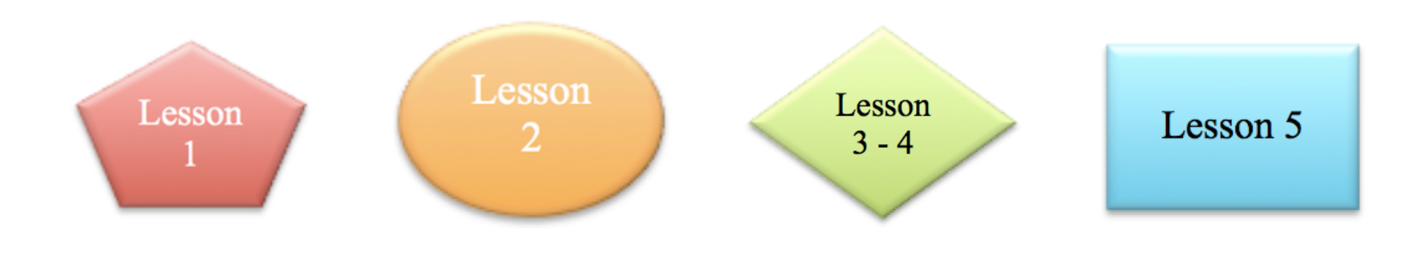
Task Constraints:
- You and your STEM partner will be a STEM TEAM for the duration of this project. You will work collaboratively and cooperatively to research, and design a play space. The percentage, fraction, or decimal of the space used for this new design is based off of an aerial map of the space with an overlay grid. Each Lesson will have its own TASK CONSTRAINTS.
- Lesson 1: One member of your STEM TEAM will download the Online STEM Notebook, and SHARE it with the other team members. All STEM Teams will survey your classmates to see the preferred play activity math. Together with the teacher, All STEM TEAMs will create a table of the results. Independently your STEM TEAM will create several graphs, or charts and pick the most convincing ones for your final presentation in Lesson 3.
- Lesson 2: You will then research play equipment and play structures that match the needs and wishes of the class. Research will be mostly pictures with captions that your STEM TEAM write.
  - You may use Snipping Tool to copy and paste pictures you find on various research sites.
  - You may use the Bing Search for Online Images and insert the pictures directly into your Online STEM Notebook.
  - You will need to know the measurements (size) the equipment needs for safe operation. You will also decide the space for one or more soccer fields, and the goals. You may add picnic tables, bleachers, or other equipment so long as you can explain the use of space.
- Lesson 3 and 4: Your STEM TEAM will create a drawing on a grid you create in Microsoft Excel Online that matches the aerial picture with the grid overlay. Your aerial layout map will have a key or legend. You will support your mathematical calculations using Microsoft Excel Online as a calculating tool. Your teacher will help you with the formulas for calculating percentages, fractions, and/or percents.
- Lesson 5: If your STEM Notebook is not presentable, you will need to Edit it so that it is presentable, or copy and paste the most persuasive parts of your STEM Notebook into a PowerPoint or a Sway presentation. Things you need to have in your final presentation include:
  - The Original Survey Data,
  - 1 - 2 Graphs that make that data understandable,
  - Your Excel map drawing of your play space design with a key or legend.
  - At least 4 Pictures of play equipment, with a caption that tells what it is used for.
  - A calculation of the square footage percentage, fraction, or decimal that your design will take up.
  - The comparison of your design versus the original survey data.

Academic Vocabulary
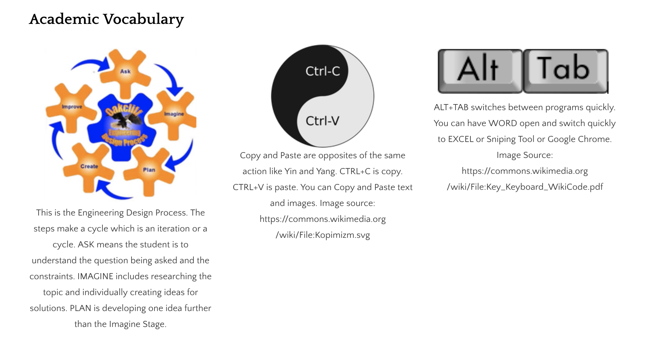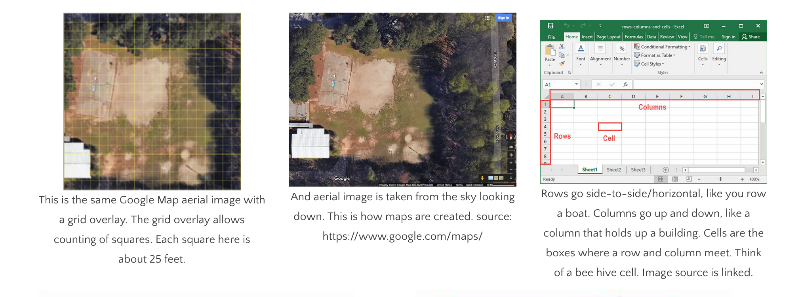
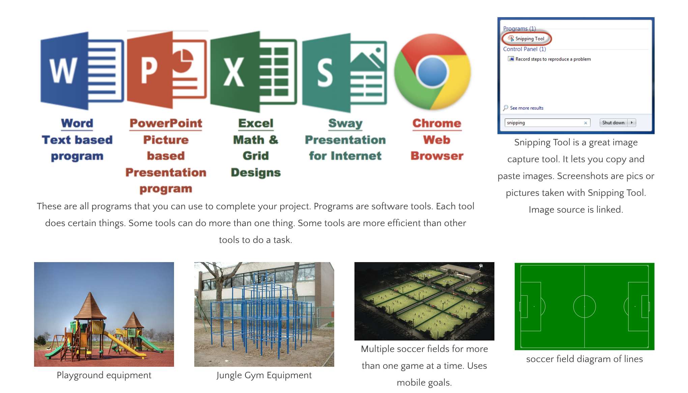

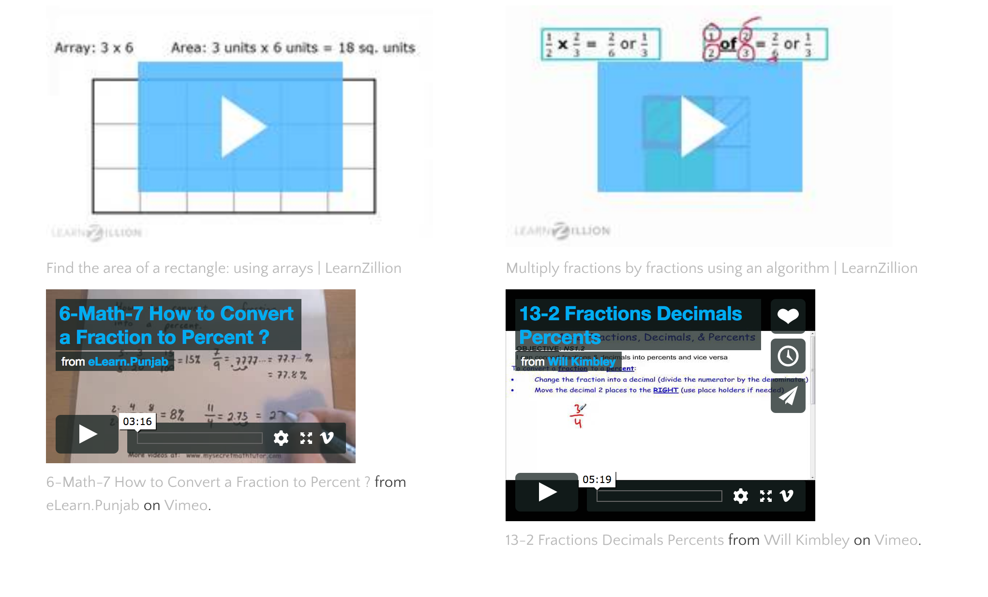

STEM Engineering Design Process - ask, imagine, plan, create, iteration, cycle
General Computer Terms - Select, compare, switch programs, CTRL+C (copy), CTRL+V (paste), save, insert
Word - Online STEM Notebook
Excel - row, column, cell, formula, equal sign, enter
Google Chrome - search bar, website URL, link
PowerPoint - presentation slide shows
Sway - presentations for the web/internet
Images - Snipping Tool, screenshot, photograph, pic, arial image, overlay
Math terms - count, fraction, percent, decimal, graph, overlay, grid, add, multiply, divide, total, equals, square, equivalent, dimensions
Playground Terms - Play area, play structure, play equipment, slides, monkey bars, swings, fields, soccer fields, goal posts, movable, permanent

Appendix C - The Lesson 1 Page

The SIOP LESSON PLAN #1:
Design Oakcliff's New Play Space - Playgrounds, Soccer Fields, and Blacktop: A STEM Unit Plan Integrating SIOP Language Goals
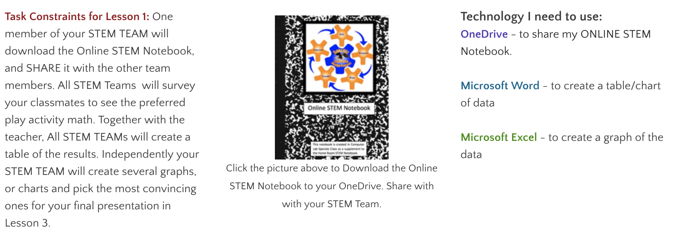
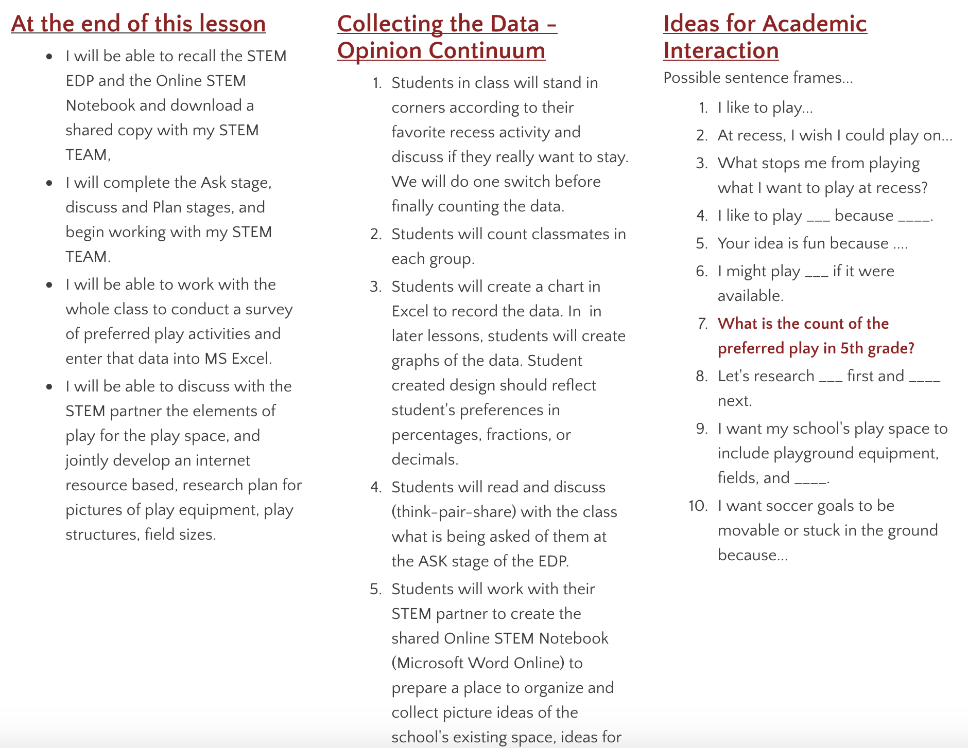

Appendix D - The Lesson 2 Page

The SIOP LESSON PLAN #2:
formatted for the ESOL Course
5th Grade Will Design Oakcliff's New Play Space Including Playgrounds, Soccer Fields, and Blacktop: A STEM Unit Plan Integrating SIOP Language Goals
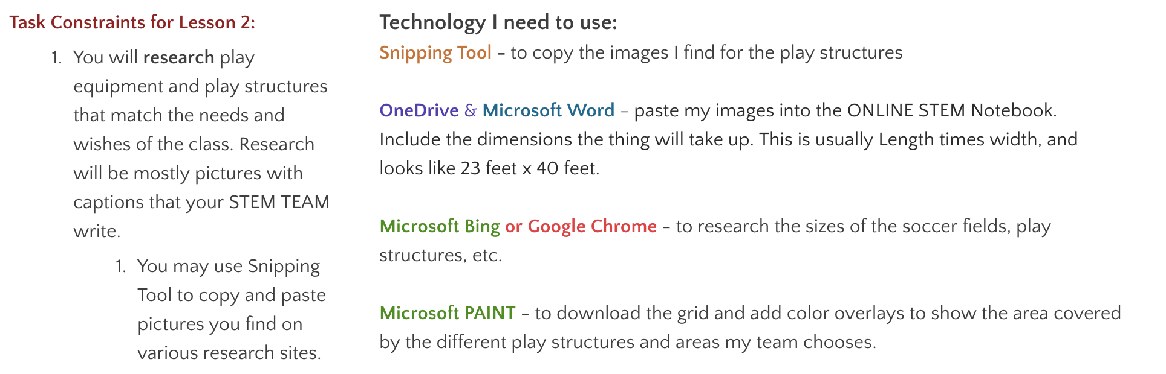
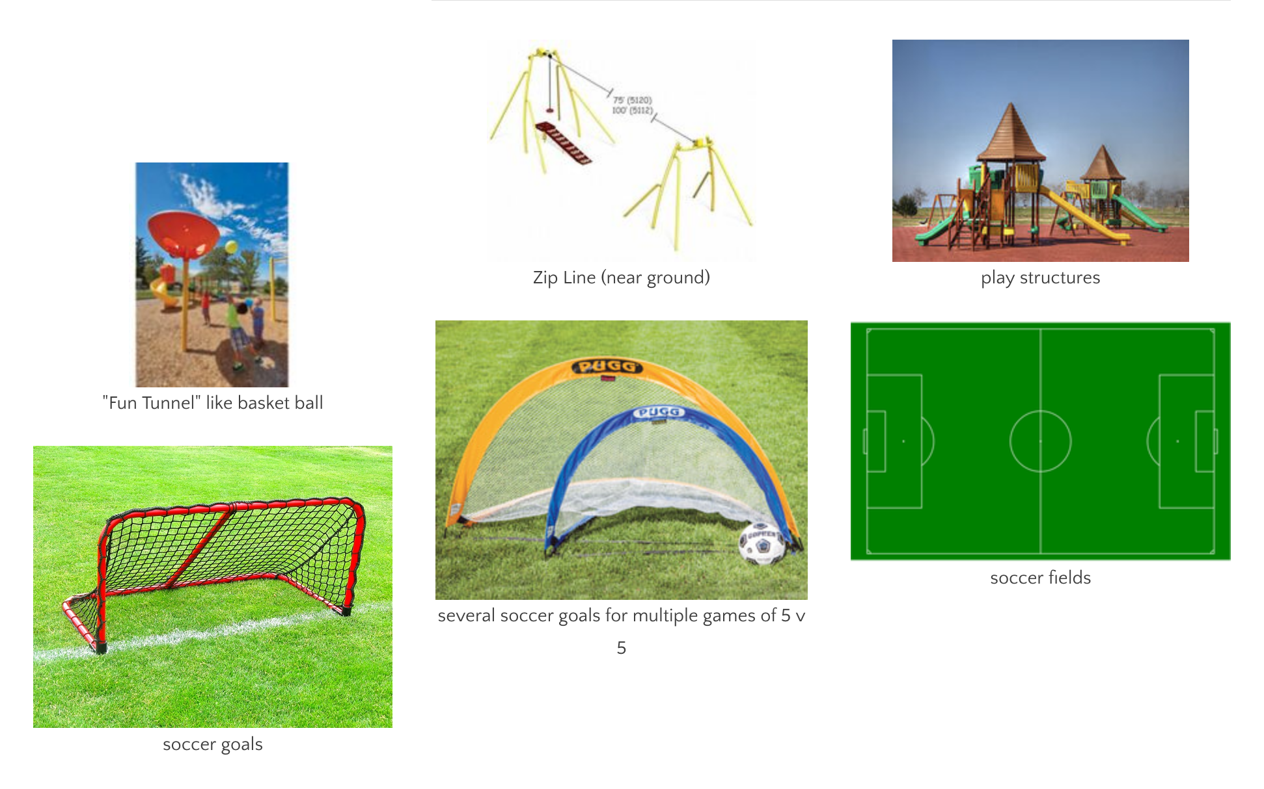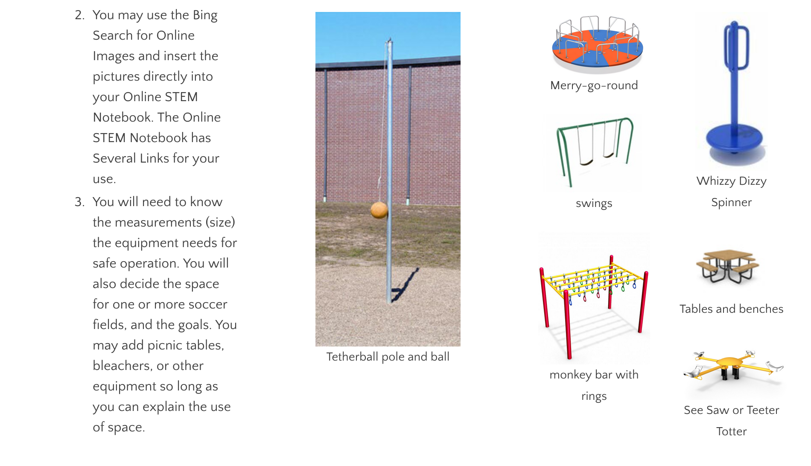
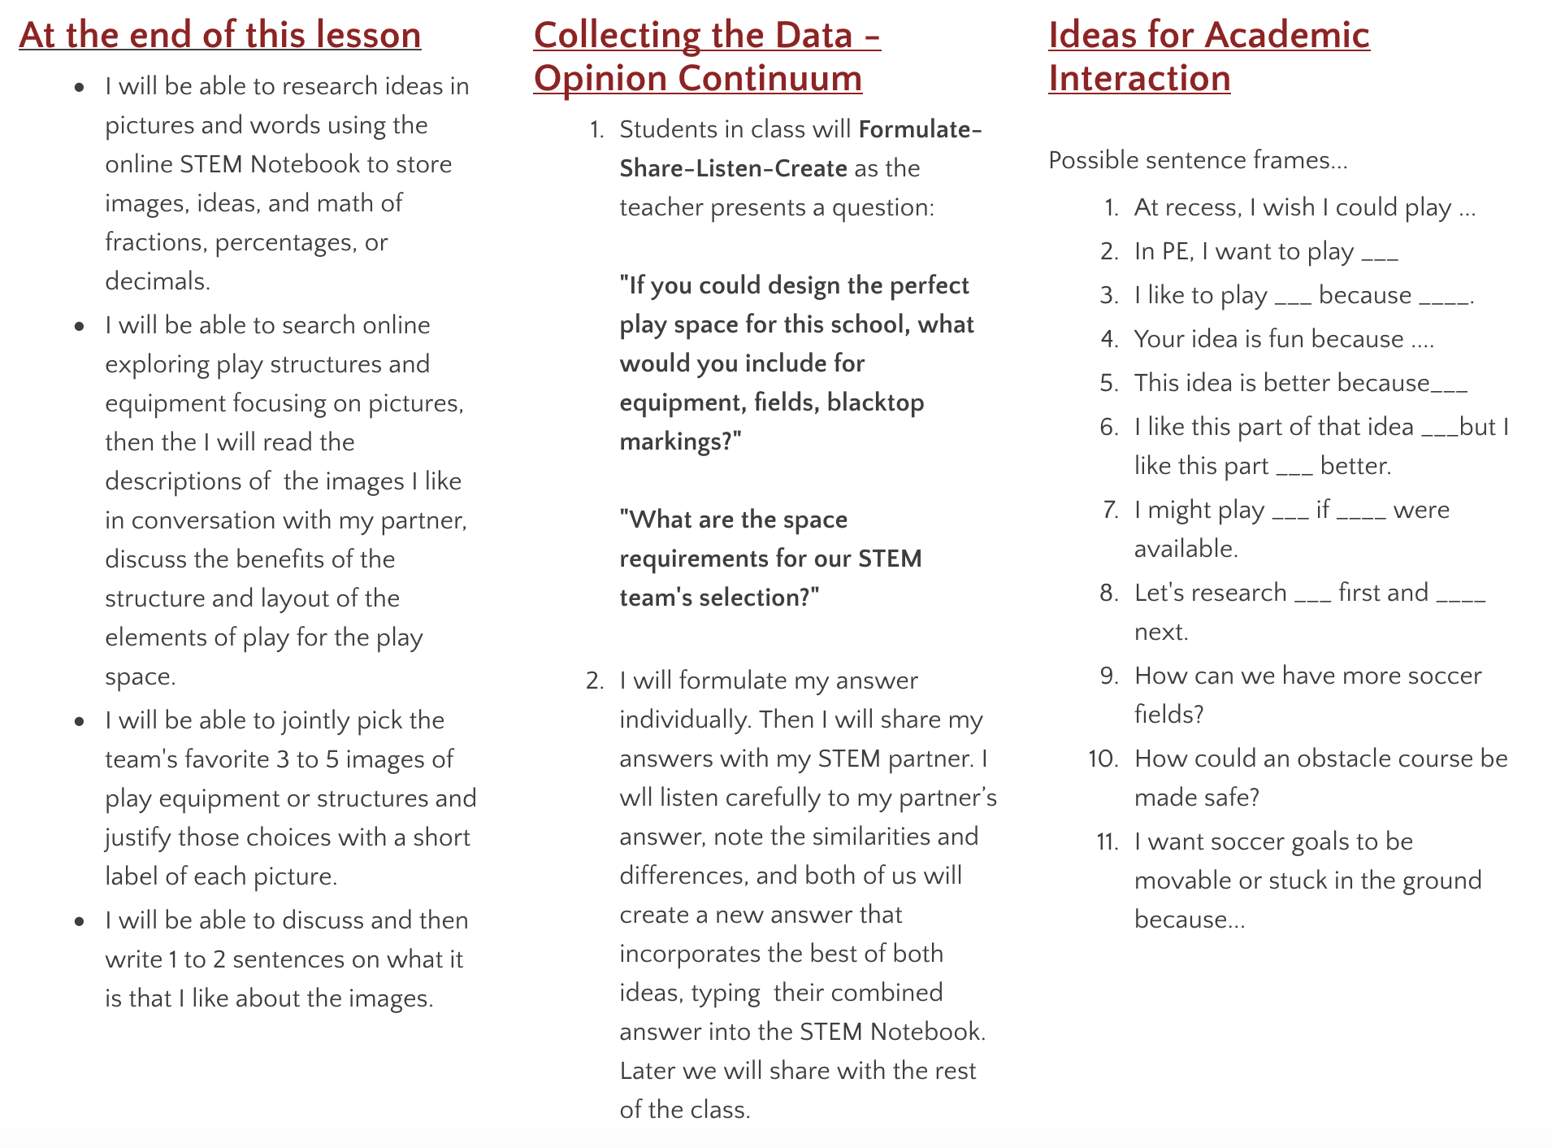

Appendix E - The Lesson 3-4 Page

The SIOP LESSON PLAN #3 and #4:
formatted for the ESOL Course
5th Grade Will Design Oakcliff's New Play Space Including Playgrounds, Soccer Fields, and Blacktop: A STEM Unit Plan Integrating SIOP Language Goals
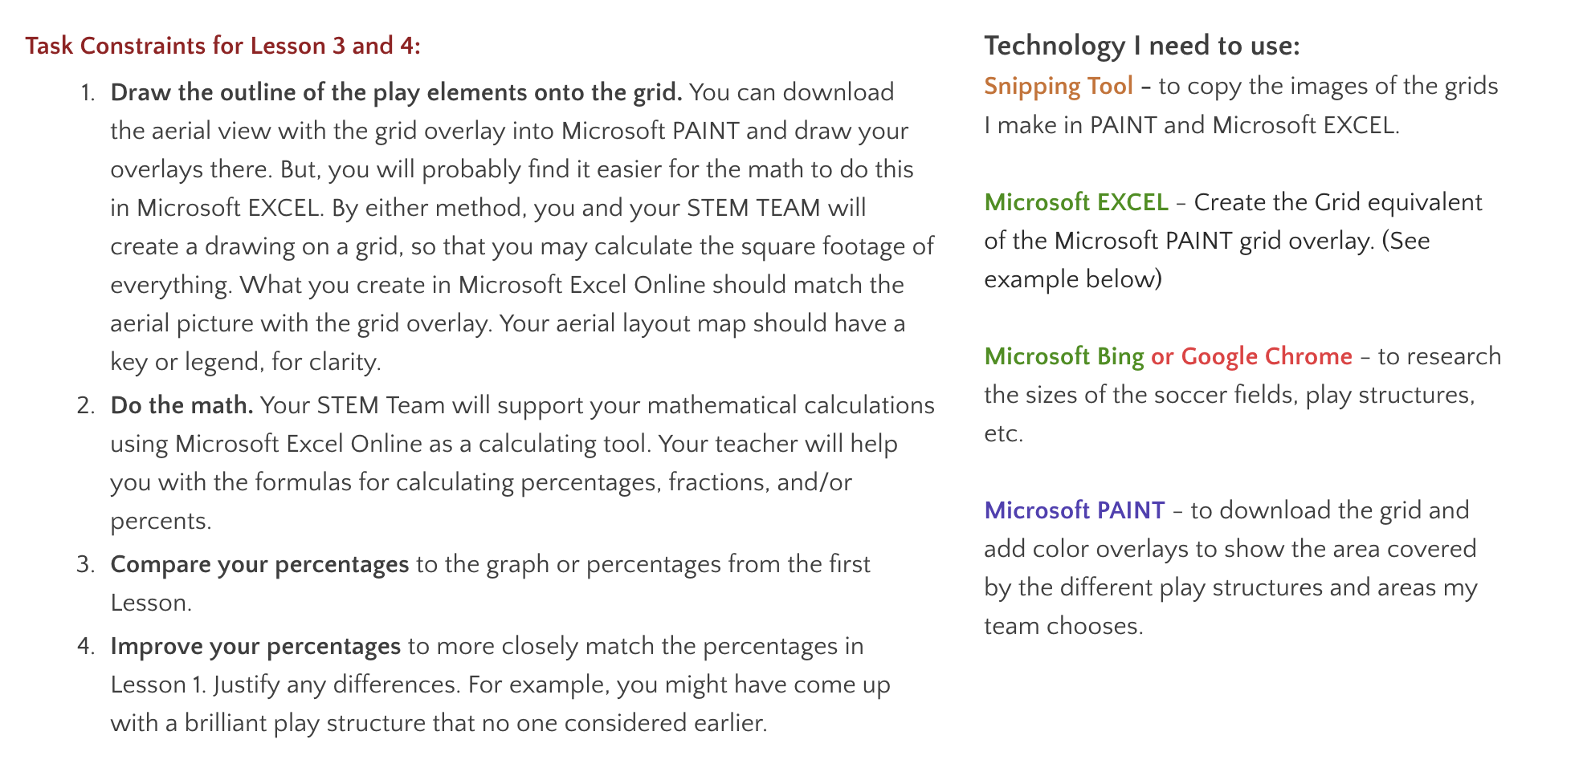
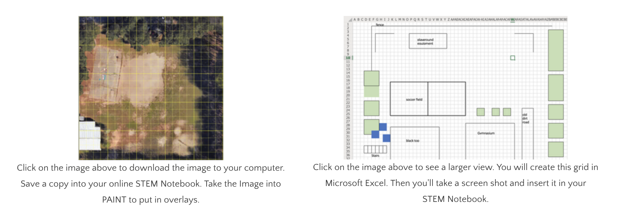
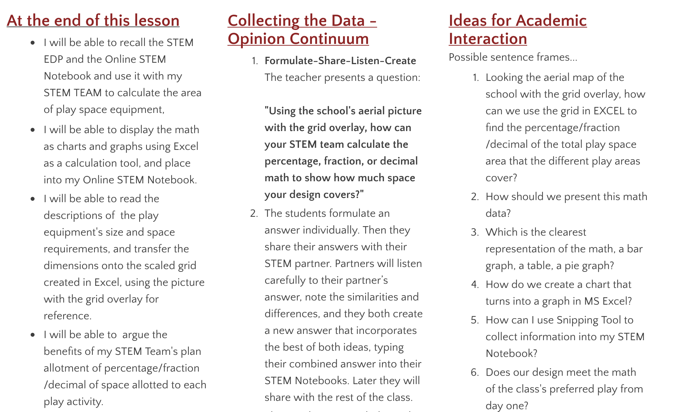
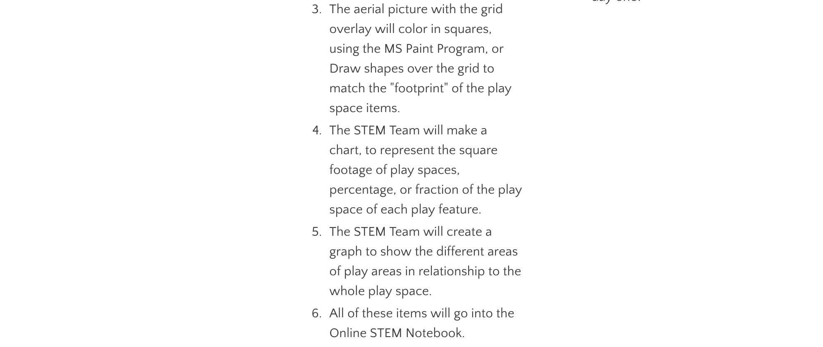

Appendix F - The Lesson 5 Page

The SIOP LESSON PLAN #5:
formatted for the ESOL Course
5th Grade Will Design Oakcliff's New Play Space Including Playgrounds, Soccer Fields, and Blacktop: A STEM Unit Plan Integrating SIOP Language Goals

Task Constraints for Lesson 5:
PRESENTATION of FINAL PRODUCT. The easiest thing to present would be your Online STEM Notebook. If your STEM Notebook is not presentable, you will need to EDIT it so that it is presentable. You may also create a PowerPoint or SWAY (copy and paste the most persuasive parts of your STEM Notebook).
Things you need to have in your final presentation include:
- The Original Survey Data, turned into percents, fractions, or decimals of the entire space,
- 1 to 3 graphs that make understandable the Original Survey Data.
- Your Excel map drawing of your play space design with a key or legend (or your PAINT overlay).
- At least 4 Pictures of play equipment, with a caption that tells what it is used for, and the dimensions in square feet.
- A calculation of the square footage percentage, fraction, or decimal that your design will take up.
- The comparison of your design percentages versus the original survey data percentages.
- Typed and spoken statements that are persuasive as to why you chose the play area and equipment.
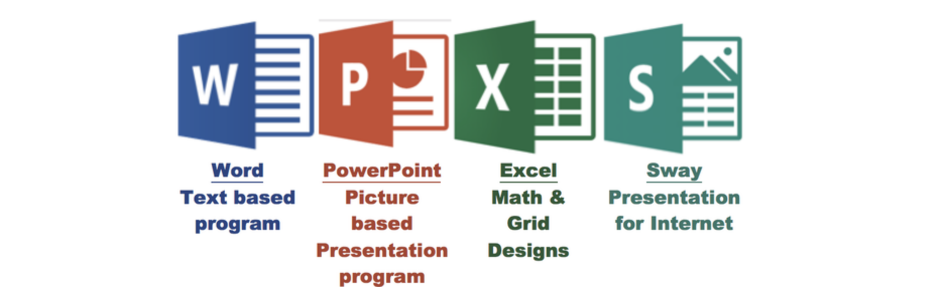

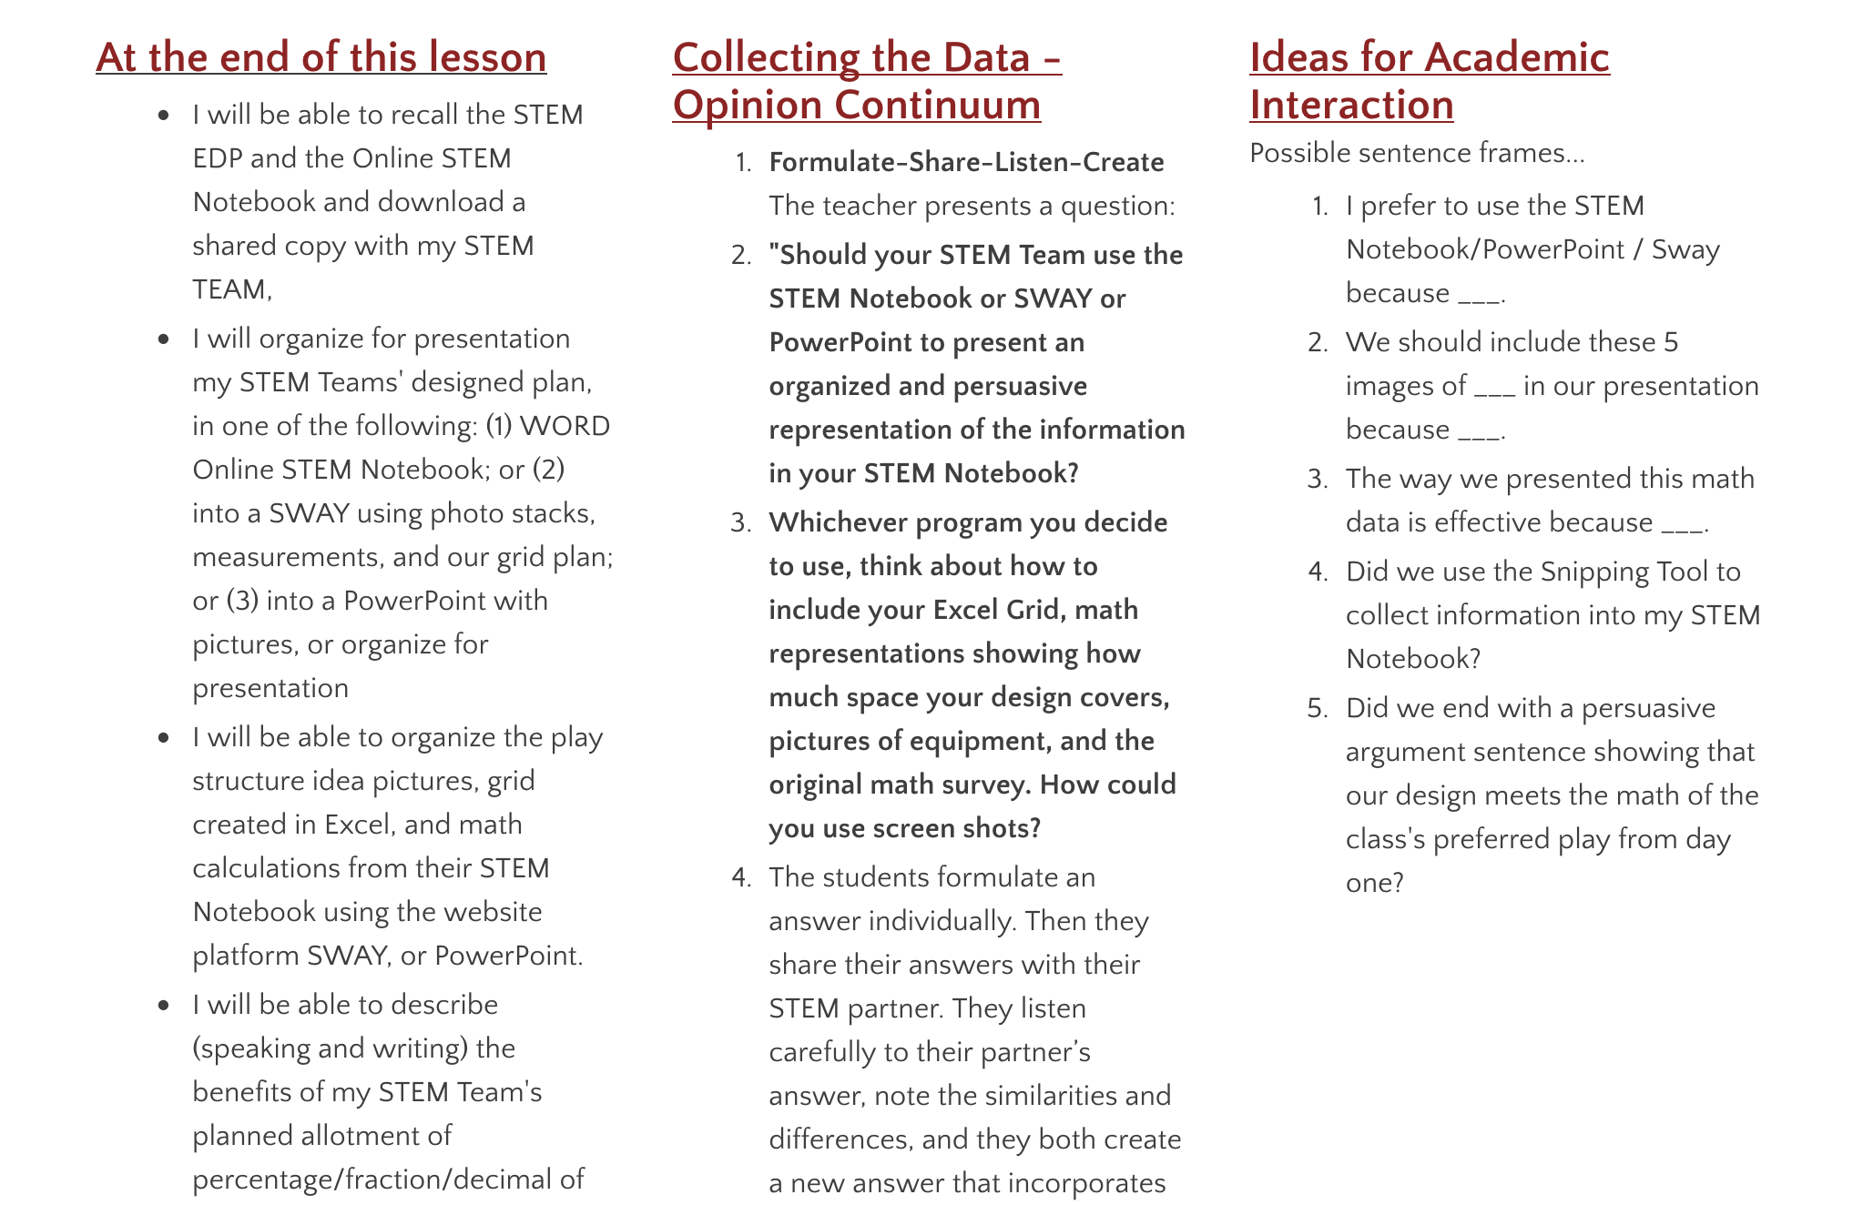
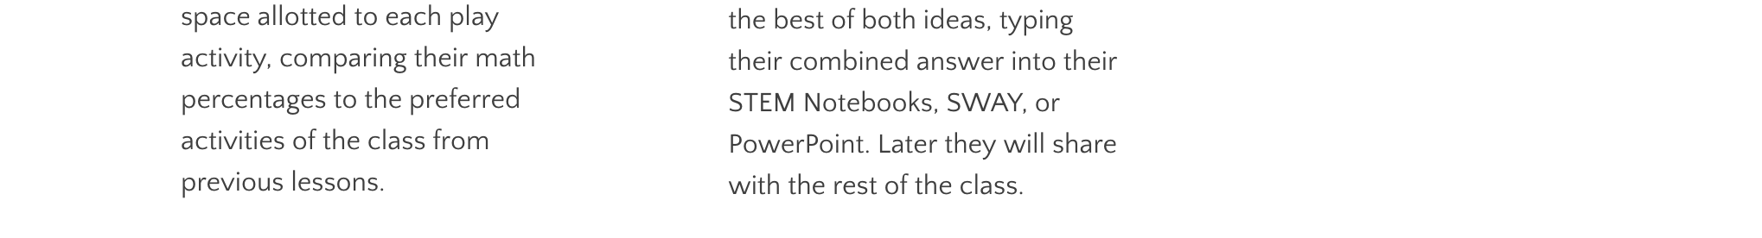

Appendix G - The Online STEM Notebook

Academic Citations are listed in this section because I read them all, digested them, and then referenced these works for the creation of much of the content of this Unit Plan. As this is a unit plan, and not a term paper, citations would have been awkward if listed internally in the paper or website version of this Unit Plan. Internal references to websites that were not academic in nature are not cited, but the links may be followed.

